VIETNAM NATIONAL UNIVERSITY
UNIVERSITY OF LANGUAGES AND INTERNATIONAL STUDIES
FACULTY OF POST-GRADUATE STUDIES
*****

TRẦN THỊ VÂN THUỲ

THE IMAGE CONSTRUCTION
OF A FEMALE PRESIDENTIAL CANDIDATE

(Xây dựng hình ảnh của một nữ ứng viên tổng thống)

Major: English Linguistics
Code: 9220201.01
Supervisor: Prof. Nguyễn Hoà

SYNOPSIS OF THE THESIS

HANOI – 2020

Công trình được hoàn thành tại:
Đại học Ngoại Ngữ - Đại học Quốc Gia Hà Nội

Người hướng dẫn khoa học: GS. Nguyễn Hoà

Phản biện 1: . . . . . . . . . . . . . . . . . . . . . . . . . . . . . . . . . . . . . . . .
Phản biên 2: . . . . . . . . . . . . . . . . . . . . . . . . . . . . . . . . . . . . . . . .

Luận án sẽ được bảo vệ trước Hội đồng cấp cơ sở chấm luận án tiến sĩ họp tại
. . . . . . . . . . . . . . . . . . . . . . . . . . . . . . . . . . . . . . . . . . . . . . . . . . . . . . . . . . . . . .
vào hồi giờ ngày tháng năm

Có thể tìm hiểu luận án tại:
Thư viện Quốc gia Việt Nam
Trung tâm Thông tin – Thư viện, Đại học Quốc gia Hà Nội

CHAPTER 1: INTRODUCTION
1. Aim of the study the and research questions
The overarching aim of this study is to investigate the image construction of Hillary Clinton in the 2016 presidential race by three key speakers – First Lady Obama Michelle, President Barrack Obama and President Bill Clinton. Her images and qualities/identities are understood and expressed in the meanings of the discourses. This reasoning grounds the first two research questions: ‘What images and qualities of a female presidential candidate (Hillary Clinton) were constructed in the three chosen speeches?’ and “how language or linguistic resources are used to construct such meanings?”. One important aspect of doing CDA is to “make explicit the relationships between discourse and social structure, showing how discourse as part of a social process, and as a social practice is determined by social structures, and what effects discourses can have on those structures” (Fairclough, 2015: 172). This pivotal task of critical studies to which the current research pertains is formulated in the third research question concerning the “why” of discourse meanings: for what purposes were these images and qualities created?
2. Scope of the study
The study focuses on the image construction of a female presidential candidate in the three speeches delivered at the National Democratic Convention held on 25th, July 2016 when the Democratic Party convened to formally recognize and announce their Party’s standard bearer to run for the White House. It adopts the dialectical-relational approach of critical discourse analysis (CDA), which draws on both social theories (power, ideology, critical, positioning, etc.,) and linguistic theories (SFG, semantics, pragmatics, rhetorics, lexis, metaphors, etc.). This approach involves three phases – description, interpretation, and explanation.
The study deals with the constructed image and qualities of the female presidential candidate, and the discursive or linguistic resources that are employed by the three speakers. In the tradition of CDA, an explanation of why such images and qualities are constructed will be offered. It recognizes that surrounding any one object, event, person, etc., there may be a variety of different discourses, each with a different story to tell about the world, a different way of representing it to the world (Burr, 1995).
The data may be described as a mix of written and spoken discourse, and will be analyzed and seen in the context of American society and its social reality – a crucial part of members’ resources (MR).
3. Contribution of the study
Theoretically, this study provides further insights into the application of CDA in social science research in general and on discursive image and identity construction in particular and sheds light on the relationship between discourse and society. It thus can help rebut many of the criticisms against CDA. Practically, it would foster the general acceptation that many social issues can be managed by the intended use of language; and it is an open question on how far beneficial effects resulted from intervention in discourse and discourse analysis could have on society. As a linguistically grounded enterprise, aiming to explore the use of linguistic resources to discursively construct images and identities, the study can offer pedagogical implications, raise critical language awareness, and lead people in the direction of change, - the change in the way we should look at women seeking powerful positions in political arena predominately operated by men.

CHAPTER 2: AMERICAN SOCIAL BACKGROUNDS IN 2016
Chapter Two presents a brief information on the social context and social situation in which the discursive event took place. It at the same time centers on the American public opinions of Hillary Clinton and of her being the very first female representing one of the two biggest parties – the Democratic Party in a presidential run -2016 while making some investigation into what Americans most want in a President in terms of qualities/identities. This chapter also examines the US Democratic Party and its issue positions as well as the three speeches.

CHAPTER 3: LITERATURE REVIEW

3.1 CDA and key concepts in CDA

CDA is concerned with the workings of power and ideology in society, and takes a specific interest in how language contributes to, perpetuates and reveals these workings (Breeze, 2011). CDA is widely recognized as an approach to language study which takes the social functions of language seriously. CDA goes beyond descriptive and structuralist thinking when it declares that it is interpretative and explanatory.
3.1.1 Power
Power remains at the core of CDA; basically, power refers to the control one has over others; it may come from “privileged access to social resources such as education, knowledge and wealth, which provides authority, status and influence to those who gain this access and enables them to dominate, coercer and control subordinate groups”, (David Machin and Andrea Mar, 2012, p. 24). It is when we talk about the persuasive influence of power where dominant groups try to get the subordinates to accept their own moral, political and cultural values and institution (ibid.). Power needs to be seen as legitimated by people in order to be accepted; in this study, power is conceived as persuasion: to sustain or change the social order, social reality the speakers tried to persuade to voters to elect Hillary Clinton for the White House. If they could persuade them to do as they wished, they were said to succeed in exercising their power.
3.1.2 Ideology
“Ideology is meaning in the service of power” (Fairclough, 1995). It limits what can be seen and what we think we can do. In CDA, the term “ideology” is understood to refer to the way that the ideas, views and values reflect and express particular interests and intentions on the part of some discourse users; hence, we have the plural “ideologies”. This study attaches to the view that ideologies are mental representations of various aspects of the social world which contribute to establishing and maintaining relations of power, domination and exploitation, (van Dijk in Wodak & Meyer, 2016). Concretely, it refers to the images and qualities/identities that were constructed in the speeches. Looking for ideology in this study here means looking for images and qualities/identities.
3.1.3 Image, Quality/Identity
Image and quality and identity are related concepts. Image is about how we are perceived or viewed by others while quality is concerned with the question of identifying “Who are we?”. It refers to distinctive attributes or characteristics possessed by some body (According to Oxford Dictionary of English). Thus, in order to construct an image of a person to others or to the public at large, it is crucial to conjure up the qualities of that person with the aim to help the listeners, readers, viewers, or information receivers envisage in their mind who and what a person is. Identity is seen as ‘the self’, referring to the fact of being who or what a person is; it at the same time concerns the characteristics determining who or what a person is (ibid.). Thus, the two terms “quality” and “identity” can be used interchangeably in this current research, and an image is viewed as being made up of qualities or identities as clarified in the sense explained above.
3.1.4 Gender
Gender and gender equality are perceived to be socially constructed rather than naturally given. Taking the critical stance in CDA, feminist linguistics desires to unravel the gender bias/ gender construction hidden in discourse. One of the questions that was floated in the run-up to the 2016 election was “is Clinton going to play the gender card?”. I believe that Clinton was viewed through this lens in the 2016 presidential run. Hence, this study looks at how her three supporters constructed her images and identities to the public, keeping this gender perspective in mind.

3.2 Prominent approaches to CDA

3.2.1 The socio-cognitive approach – Teun van Dijk
This approach posits that discourse is a multidimensional social phenomenon which is a linguistic object, an action, a form of social interaction, a social practice, a mental representation, an interactional or communicative event or activity, a cultural product, or even an economic commodity that can be bought and sold (van Dijk, 2009, p. 66-67).
- Van Dijk focuses on the cognitive interface between the textual and the social.
- His analysis framework consists of Description of Text and talk at all levels + Discourse’s role in society + mental cognitive interface
- Van Dijk’s critical linguistics work is not strongly attached to, or drawn upon SFL.
3.2.2 The discourse-historical approach – Ruth Wodak
A key defining feature is its recognition of the role of historical context in the interpretation of discourses, allowing the reconstruction of recontextualization as an important process linking texts and discourses intertextually and interdiscursively over time. It also recognizes that fact that “grand theories” can be used a foundation, but “middle-range theories” can serve better as theoretical basis of CDA, (Reisigl and Wodak, 2009).
- Her work comprises bodies of material looking at racism spanning decades to see continuities and differences.
- Ruth Wodak proposes 3-dimensional model, including: Analyzing the topics/contents, Investigating the discursive strategies and Deconstruct linguistic means and linguistic realizations of discursive practices
- Her model is lesser oriented to SFL

3.2.3 The social actors approach - Theo van Leeuwen
Theo van Leeuwen represents the social actors approach (SAA) to CDA. Following SAA, participants in discourses are referred to as social actors. They permanently constitute and reproduce social structure, models of the world. The theoretical core of SAA is based on the idea that ‘discourses are ultimately modeled on social practices’ (van Leeuwen, 2009, p. 145). The social practice is primary, the representation of social actors is based on what people do and thus texts – the evidence for the existence of discourses – should be interpreted as representation of social practice.
In SAA, the categories put into analysis are nomination and agency (sociological categories) rather than nouns or passive sentences which belong to linguistic categories. Also, while examining linguistic and rhetorical phenomenal, the elements scrutinized are linked through the concept of ‘social actors’ such as ‘nominal groups’ (van Leeuwen, 2008, p. 25).

3.2.4 The dialectical-relational approach – Norman Fairclough
Fairclough (2001, 2015) offers a three-dimensional analytic framework which sees discourse as text, a discursive practice and as a social practice. The analysis should focus on describing the linguistic features of the text (text), the production and interpretation processes (discursive practice – how discourse producers draw on linguistic resources to create a text, and how receivers of texts apply linguistic resources to make sense of the text, and the wider social practice the communicative event belongs to (social practice). It is important to keep in mind that the relationship between texts and social practice is mediated by discursive practice (Jorgensen and Phillips, 2002). Fairclough warns that we need social and cultural theories to inform CDA because the goal of CDA, as commonly agreed to by many scholars, is to explore the links between language use (discourse as social interaction) and social practice. It should be noted that the dialectical-relational approach draws on systemic functional grammar as a tool for textual description. Following is the figure representing this framework (Fairclough, 1995).

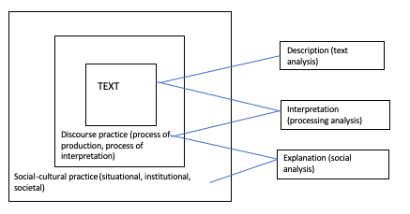

Figure 1.1 Norman Fairclough's framework (1995)
Halliday’s Systemic Functional Linguistics (SFL) as applied in the study
Fairclough’s approach draws on Halliday’s Systemic Functional Grammar theory as he once claimed that, SFL is main tool to view language in its social context, and with SFL, language is seen as an instrument of social construction, rather than a formal, cognitive system where language is studied in separation from social environment. SFL is used in analyzing textual description (linguistic items). A key pillar of SFG is the view that the clause is seen as representation described in terms of the notion of “transitivity” involving “process”, “participants”, and “circumstance. In the ten-guiding questions in the stage of description, Fairclough refers a great deal to “transitivity” Basically, SFG is concerned with the three meta-functional of language: ideational, interpersonal, and textual; Each metafunction has its own principle system in the networks for clauses; thus, we have the transitivity system as the principle system for the ideational metafunction in the clause network. For the reality is made up of processes, a process consists of, in principle, three components: the process itself; participants in the process; and circumstances associated with the process and they provide the frame of reference for interpreting our experience of what goes on.
Halliday proposes six types of processes and particular kinds of participant role that are systemically associated with each.
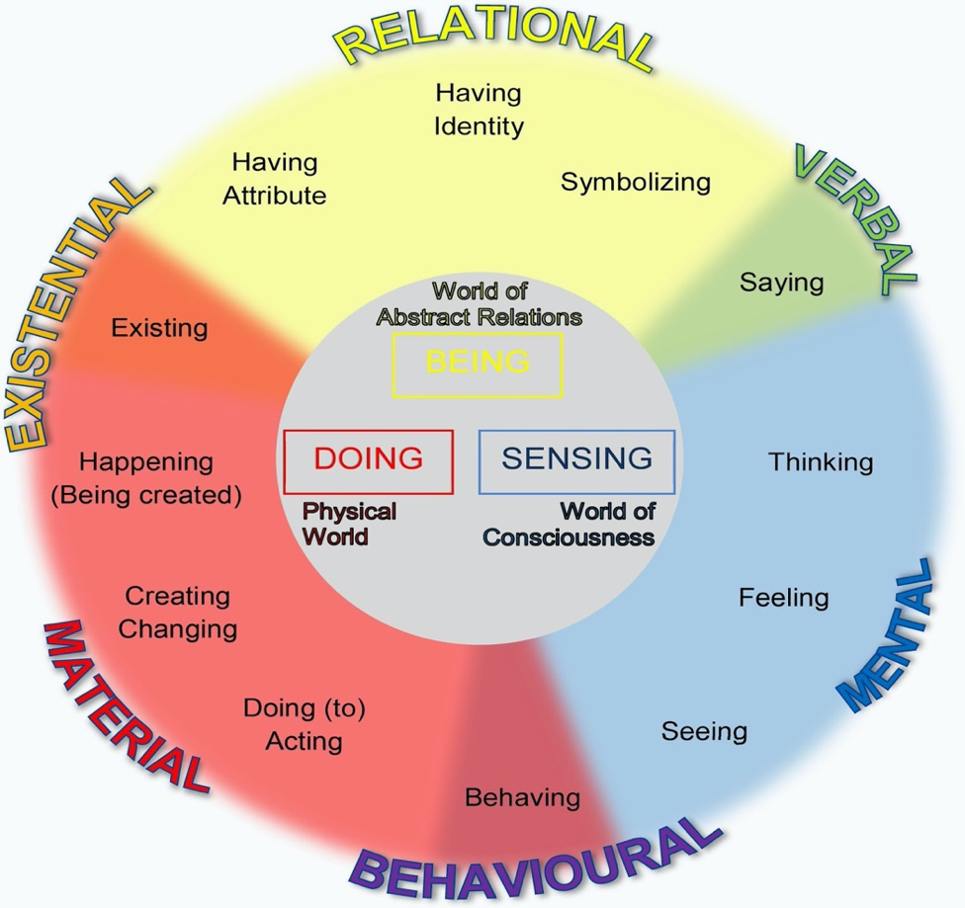
Figure 1.2 The grammar of experience: Types of process in English (cited in Halliday 2000, p. 109)

CHAPTER 4: RESEARCH METHODOLOGY
4.1. Research design
The research design for the current investigation is the case study with the purpose of identifying linguistic image construction of a presidential candidate via an in-depth study of three cases (three written discourses); and also, from this basis, bringing into the foreground the linguistic resources and strategies used to convey ideologies on a woman in politics. The case in this study is the construction of Hillary Clinton as a presidential candidate in the three keynote nominating speeches delivered by the Other (former President and her husband Bill Clinton, the then First Lady Michelle Obama, and President Barack Obama) at the 2016 Democratic National Convention held at the Wells Fargo Center, Philadelphia, USA.
4.2. Research methods
Descriptive and interpretative analysis
Designed as a qualitative research, this study employs the descriptive and interpretative methods; and the units of description and interpretation include the formal features: lexical, grammatical items, and the macro structure of discourse that appeared in the three speeches, and the co-text and context of the research data (three speeches) which are inclusive of linguistic environment of words, phrases, sentences and paragraphs inside a text or/and inter-texts; and social environment in which the discourses under analysis occur.
Critical analysis
In the present study, the analysis goes beyond description and interpretation; it involves the process of explanation and evaluation, reflecting on information gathered from the co-text, context, formal features of the chosen texts.
The three chosen speeches were not treated as ‘facts’, but rather as a site where the power to persuade the voters to vote Clinton through ideologies was exercised. Ideologies in this case in essence refer to the images and identities that were conjured up. Our explanation tried to explain how social practice via the mediation of aspects of MR like culture, values, beliefs, ideologies, etc., determined the construction of Clinton as presidential candidate. In other words, Clinton was what and who the three speakers wanted her to be perceived and viewed.
  - Analytical framework of the study: The adoption of Norman’s analytical framework (In line with the theoretical framework, See Figure 1.1)
The description
I followed the suggestions offered by Fairclough (2015) in describing the formal textual features of the three chosen speeches. In particular, I gathered and made sense of the linguistic resources and discursive practices that were deployed by the speakers at the same time. As Fairclough draws on systemic functional grammar as a tool of the trade, the experiential, relational and expressive, values of words and grammar were examined, described and interpreted as they occurred to construct Clinton. The large-scale structures of the text are taken to in the analysis of the argumentative nature of the texts when the three discourses are seen as a big argument where the speakers framed their arguments to make a convincing case for the candidate via diverse topics (different themes) on their delineation of a woman in politics.
The interpretation
Content and thematic analysis was applied to arrive at determination of images and qualities. I was fully aware of the strengths and weaknesses of this method. The advantages include the possibility to directly examine discourses, allow for quantitative and qualitative analysis, and provide insights into the complex models of human thought and language use. The downsides can be time-consuming, possibility of errors, prone to reductionism, etc. In order to enhance validity and minimize coding errors, I did the re-coding after a period of one month. Basically, the results matched well, with few minor differences. Another step was having two of my colleagues, who are knowledgeable in CDA, and has had experiences of doing content analysis do the coding. Fortunately, the results matched about 95%. We discussed the differences and I made the final determinations.
The explanation
In this study an effort was made to find out how the social determinants of power (social reality and relational power demonstrated in the construction of Hillary’s images and identities) at situational, institutional and societal levels helped shape the three speeches. The ideologies under discussion in this study refer to the elements of MR which can be culture, values, beliefs, identity, favored by the Americans. They mediated the speeches as ideological in character. I also made an attempt to fathom if these three speeches were normative with respect to MR or creative. Simply put, were they just what they were as expected following the values and norms of American society, the Democratic Party, and of the situation, or different”? Did they successfully contribute to presenting candidate Clinton in a favorable light?
The interweaving of the three stages in the current study
In practice, it was also impossible to separate the first two stages of description and interpretation with the reason being there is no way to separate the formal features with the actual meanings as used in context in which they are construed up. As we view the linguistic cues, our MR is activated simultaneously to help us make sense of the what the discourse is about. The analysis of vocabulary, grammar, and textual structures facilitates the analysis and the understanding of the interaction which involves the processes of production and interpretation. It is critical to note that the analysis of the interaction should be based closely on the ‘cues’ and ‘traces’ – formal features, that appeared in the text. The merging of the stages is meant to acquire the answers to such questions as: What images (and qualities/identities) of the female presidential candidate were constructed? How were they constructed?
Explanation has a strong connection with the two previous stages, especially when the issue of power relations and ideology is in question. On the one hand, when we address what and how her images were constructed, we at the same time touch on the power relations presented in discourse at three levels: situational (between speakers and hearers), institutional (parties involved) and societal (speakers’ thoughts, culture, values, attitudes, receptions towards the matter discussed in the discourses; speakers’ positions and social perception of women in a men-dominated political arena). On the other hand, when we look at the impacts of the discourses on the society at three levels (situational, institutional and societal), and at some kind of social change in attitude about the women’s involvement in top-notch positions in societies, we have to base on the description and interpretation of the meanings of the discourses.
  - Data collection procedures
Data collected
I collected the three transcribed speeches from the following source:
https://edition.cnn.com/2016/07/26/politics/transcript-michelle-obama-speech-democratic-national-convention/index.html (retrieved on July 26, 2016)
https://edition.cnn.com/2016/07/27/politics/bill-clinton-speech-transcript/index.html (retrieved on July 27, 2016)
https://www.politico.com/story/2016/07/dnc-2016-obama-prepared-remarks-226345 (retrieved on July 28, 2016)
The data gathered for this study is real, authentic, and natural. It belongs to the genre of political speech. The selection of those speeches is expected to realize the aim of this study: the description and explanation of how a discursive image and identities of a female presidential candidate was delineated. The homogeneity of the background information can inform the discussion of the findings. The three speeches were analyzed in their full contexts; thus, the collection of relevant information was also conducted.

Figure 2.1. Social political contextual information gathering procedures
  - Data analysis
The data of this study were analyzed in their contexts. And they were processed as follows,
The coding process started with open coding which aimed to identify any useful formal features (as suggested by Fairclough, 2015). In fact, the range of formal features was quite diverse from words, phrases, sentences, or paragraphs, or any that can serve as a cue to trigger the activation of our MR. To make it easier to follow, all the lines were numbered, and the cases (the three discourses) under investigation were coded C1 for case one (Michelle Obama’s speech), C2 for case two (Barack Obama’s speech) and C3 for case three (Bill Clinton’s speech). An example of the result of my coding is given below for illustration. Words and phrases such as
Advocating for kids with disabilities (C1, line 45)
Fighting for children’s health care and for quality child care in the Senate (C1, line 46)
Travelling the globe to keep our kids safe (C1, line 51)
Doing anything to help our children thrive (C2 line 78)
can conjure up the values/ qualities of “compassion” for children, which in turn contribute to creating the image of the “children’s defender/protector”.
Some of these formal items constitute a frame also known as semantic field. For example, “children, care, safe, help” in the above examples constitute a semantic field, which may be called “care or compassion for children”. Thus, my next steps were axial coding, which identified the relationships among the open codes – in this study. The results of this process refer to the qualities/ values that were constructed to make up the images, for examples, the values of “compassion for children, trust and empowerment”. The last step in this process is selective coding which is undertaken to figure out the variables that involves all of the relevant data – that is, the images, for example, the images of “children protector/defender, a working wife and mother, and a viable presidential candidate”. This step was realized through the process of thematic identification, which drew on from all the specific values and qualities.
CHAPTER 5: FINDINGS AND DISCUSSION
  - Images of a female presidential candidate
The overarching aim of the three speeches under investigation was to make a “sales pitch” for Hillary Rodham Clinton in America’s 2016 presidential election, championing her fitness for the job of President and Commander-in-Chief. The speakers together portrayed the candidate in terms of a wealth of qualities, which in turn conjure up the desirable images. Our findings suggest three images of the candidate as a children’s protector and defender, a full-time working wife and mother, and a viable presidential candidate can emerge.
5.1.1 The image of a children’s protector and defender
The image of Hillary as a fighter for children’s well-being and rights was constructed based on a combination of qualities which are most admired in a president. They were compassion, Empathy, Openness, Trustworthiness and Empowerment. Her supporters aimed to sell her image to the public as a person who cared, always prioritized the kids’ benefits; did act to bring good things to them. When children are considered the future of the nation, protecting them and acting out for them would mean caring for the country for now and for the ensuing time; and thus, for that reason, under her supporters’ pens, her image would be endearing to voters.
5.1.2 The image of a full-time working wife and mother
Hillary Clinton’s image as a full-time working wife and mother was studded with such qualities as Relaxation, Being a caring and devoted mother and Being an independent, yet supportive wife. Hillary was constructed as a person who enjoyed and lived a life as a normal human being. She was envisaged as a woman of family and she was the same as any American woman, ‘being first and foremost a mother’ (C3, line 166) to her child and a helping hand to her busy husband who was himself a former president of America. And this caring and devoted mother and wife was further delineated with the image of a diligent public servant, showing her independence though being a wife of a governor and later of a president.
5.1.3 The image of a viable presidential candidate
So many qualities were attributed to Hillary Clinton’s image of a viable presidential candidate. These profuse traits include Having a vision, Experience and Commitment to work, Ability to deliver, Staying the course, Resilience, Optimism and Sharing American values, Being an admirable person, Having Stamina and Being real. In order to convince Americans that Clinton fitted for the position of the president of the country, Hillary Clinton’s supporters pertained each of her images with their corresponding qualities so that the overall picture of hers would encompass all the needed or more than needed qualities which are most wanted or desired in a president, proving her to have the whole package for the highest VP position of the society. Hence, the core values of a presidential hopeful, Hillary Clinton, who was a true public servant working for every American (nation’s Children, American citizens and her beloved ones) were Compassion, Empathy, Openness, Trust, Relaxation, Experience, Commitment, Ability to deliver, Vision, Resilience.
With Hillary Clinton’s three prominent images described and constructed by her supporters in their discourses, it is possible to visualize her images with attributed qualities as in the following graphic.
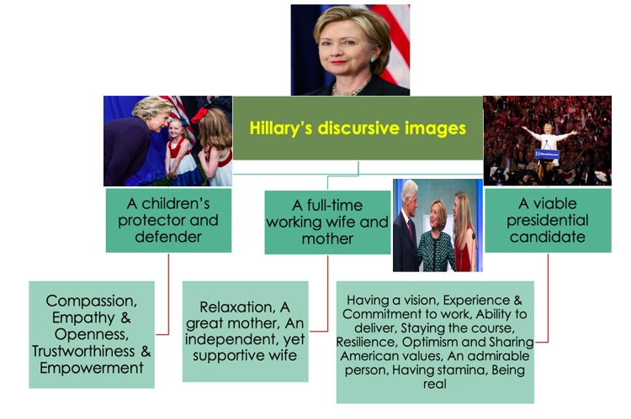

Figure 3.1. Hillary Clinton's discursive images
Addressing the second research question concerning how these above images and qualities are linguistically constructed, my analysis based on Fairclough’s suggestions shows that all these images and qualities were creatively constructed by the smart and effective use of linguistic resources and discursive strategies. Prominent among these are:
The main linguistic resources
The careful word choice including well-meant use of words (as in the examples (13), (17), (19), (29), (32)); antonyms (the examples (5), (19)); the flux of words in one spot (examples (16), (19), (27), (34)); hyperbole (4) to further bring into foreground the exemplary qualities of Hillary Clinton.
The use of metaphor based on the affinity or similarity of certain properties or features of the two corresponding concepts (as in the examples (27), (9), (30) to resonate the prominent image of Hillary. Though the contextual meaning excludes dictionary meaning, her image can be accessible to the public thanks to the familiarity and closeness of things/ persons brought up to associate her with.
The use of material processes so as to construct her as a doer, a performer who actually does, and acts not just talks and means well to make changes (as in the examples (4), (7), (10), (16), (23), (26), (33), (39).)
The parallel structures with identical, similar syntactical structures in two or more sentences or parts of a sentence which are backed up by repetition of words to do the mission of creating the emphasis on her qualities/values (as in the examples (2), (3), (10), (15), (27), (28), (38).)
The main discursive strategies that were deployed by the speakers include:
The rhetoric of comparison and contrast as seen in the examples of (8), (10), (16), (30) to mingle her with her league (US) or to set her apart from the opposite side ‘THEM’, or setting her apart from the opposing side in order to convince people that she is the right option in the presidential race
The rhetoric of symmetric way of writing (as in the examples (16), (29) helps promote the wholeness of the quality description.
The use of facts, famous and influential figures inside American society to back up the authenticity and trustworthiness of the arguments (as in the examples (1), (4), (8) (22), (24), (25)).
Maximizing her strengths while barely mentioning her weaknesses like exalting her lifetime devotion to the nation’s kids throughout her various positions, and her resilience in the cause of shattering the hardest glass ceiling. The following diagram represents the use linguistic resources used in the three speeches.
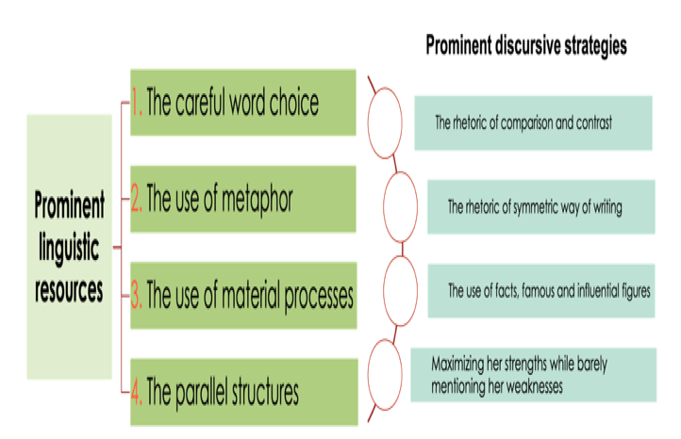

Figure 3.2. Prominent linguistic resources and strategies to depict Clinton’s images
  - Messages on a woman in politics
The findings show that Ms. Michelle Obama, Mr. Barack Obama and Mr. Bill Clinton were Hillary’s supporters, from the same Party and deriving their intentions from the same social reality concerning the presidential race 2016 in which Hillary Clinton was a candidate; thus, they shared the same overarching aim of championing Clinton to be the president of the Unite States. Together, they depicted Hillary Clinton’s images favorably to the American via the aforementioned images and qualities. However, the discourses materializing and reifying their thoughts and views of Clinton and the social reality affecting their discourse constructions were mediated by MR (member’s recourses including their context interpretations); therefore, in their respective discourse, each opted for a certain aspect in Hillary’s images to describe and emphasize. The first case made Hillary’s image of children’s protector and defender its focus; in the case two, it was Hillary’s image as a viable presidential candidate attached to American values and optimism and the case three put more stress on her image of a devoted married woman who worked fulltime as a public servant. The mediated relationship between the discourses and the social reality leads to the differences in Hillary’s supporters’ propaganda on Hillary as a woman in politics and also their tactics of approaching a social phenomenon and presenting it to the public.
The saliently projected qualities/identities helped communicate the core messages of a woman in politics, which each speaker strived to convey to Americans in order to propel her into the White House.
5.2.1 A role model in the White House for the nation’s children
Michelle argued for the presence of a female in the White House in the next presidential term via her mentioning Hillary as a parent – a role model (C1, line 25) -being a champion for nation’s kids: ‘…, Hillary has spent decades … to make a difference in their (children’s) lives … advocating for kids with disabilities as a young lawyer, fighting for children’s health care as First Lady, and for quality child care in the Senate.’ (lines 43-46). Hillary was further depicted as the hope, the pride and the history of America: ‘…Hillary Clinton … has the guts and the grace to keep coming back and putting those cracks in that highest and hardest glass ceiling until she finally breaks through, lifting all of us along with her.’(C1, lines 86-88). And, in the end, the core message that Michelle wanted to convey to the public was the necessity of having a female role model in the White House; and her story and mission resembled the story of America.
Story of Hillary | Story of the nation
She lost in the democratic nomination 2008 with eighteen million cracks (votes) | In the past, people suffered from the lash of bondage, the shame of servitude, the sting of segregation
She kept coming back in 2016 with the guts and the grace to put those cracks in that highest and hardest glass ceiling | People kept on striving and hoping and doing what needed to be done
Now because of her, sons and daughters take for granted that a woman can be President of the United States | So today, a black woman is first lady of America living in a house built by slaves
5.2.2 A woman in the arena
Unlike Michelle Obama, who tried to deliver the image of Hillary as a role model in the White House for the kids nationwide, Barack Obama chose a different message on Hillary to convince Americans to vote for her; and that was a ‘tough’ woman in the political arena. The woman in the area like Hillary Clinton was the one with the mission of breaking through glass ceilings: ‘There is only one candidate in this race …. A leader with real plans to break down barriers, and blast through glass ceilings, and widen the circle of opportunity to every single American – …, Hillary Clinton.’(C2, lines 76-80); being better than men: there has never been a man or a woman, not me, not Bill, nobody, more qualified than Hillary Clinton to serve as president of the United States of America. I hope you don’t mind, Bill, but I was just telling the truth, man.’(C2, lines 109-11); Facing the hard side of politics: ‘Hillary’s got her share of critics. She has been caricatured by the right and by some on the left; she has been accused of everything you can imagine – and some things you cannot…’ (C2, lines 217-218);
Hillary was the one in the Teddy Roosevelt’s saying: ‘…Teddy Roosevelt once described – not the timid souls who criticize from the sidelines, but someone “who is actually in the arena … who strives valiantly; who errs … but who at the best knows in the end the triumph of high achievement.”’(C2, lines 222-224) because she was a woman in the arena.
5.2.3 A working wife and a normal mainstream wife as the best change maker
Bill Clinton merged Hillary’s personal life with the longevity of her political career; creating a soft side of her in the position of a mainstream wife and mother beside her being a tough person of work so as to advocate for ‘that warm and real Hillary’ to be the best change-maker for everyone: A woman in politics was the best change maker, always trying to get things done, making a difference and brining positive change to people’s lives. Bill Clinton repeatedly used the term ‘change-maker’ to characterize his wife (in seven spots throughout his speech); and he did not resort to the simple and workaday word, ‘changer’, meaning a person who changes something. With the work ‘change-maker’, the meaning would be more abstract and have positive effects on the audience about the first female presidential candidate of a major party who had the whole package, be it her knowledge and conviction, her wit and character, her decency and determination to sweep out all encumbrances so as to create or bring about positive and better transformation and development to everything and to everyone; and because of this, she was advocated as ‘the best darn change maker’.
  - Strategies to depict a woman in politics to the public
Hillary was seen and portrayed from three different prisms; thus, though all three cases gave a favorable voice to her, they bordered on different tactics in delivering her images and messages of her – a woman in politics - to the public.

5.4. The dialectical relationship between the discourses and American society
The connections between images and qualities attributed to Hillary Clinton in the 2016 presidential race and the differences of her depictions manifested in the three chosen discourses can be explained via the dialectical relationship between the discourses and the social reality. Hence, the answers to the questions of “how” and “why” such images of Hillary Clinton were constructed requires the explanations from this two-way relation.

Situational
(issues surrounding the DNC)
Institutional
(Party’s positions and platform…)
Societal
(Social opinions on events, issues concerned…)
Determinants
(social reality)
Societal
(possible social change or a new social reality after the DNC)
Institutional
(Party’s positions and platform…)

Situational
(Situational effects after the DNC)
Effects
(social reality)

MR
(Hillary’s supporters)
MR
(Receivers)
Hillary’s image construction
(Discourses)

Figure 3.3 Dialectical relationship between discourse and society

5.4.1 Social reality affecting the discourse
The speakers of the three chosen discourses, starting from their overarching purpose of championing Hillary Clinton as a natural fit for the presidential position, had to take into consideration the social reality at social, institutional and situational levels to construct Hillary Clinton’s images to the public. Thus, through the description and interpretation of the discourses, we can see that the three prominent images of Hillary with multiple of qualities were in line with social reality.
Firstly, most of qualities constructed for Hillary Clinton were found in any lists of qualities that Americans want in their president such as compassion, empathy, resilience, have a vision, can deliver, stamina, experience and commitment, etc. However, there were some qualities of Hillary Clinton appearing in the discourses such as being a great mother, an independent and supportive wife which one could not find in any lists of American president’s traits and values. This discovery could be explained by the fact that Hillary was very first woman in America to be a presidential candidate from the Democratic Party and the lists of the qualities Americans most want in their president which see the absence of the qualities adherent to family matters just show the long standing association of the presidency with men in the United States. And thus, in the case of Hillary Clinton, her supporters had to construct her with more qualities than needed outside the ‘normal list’ in order to convince the public that she was up to the job.
Secondly, in 2016 the Democratic Party made it clear about the gender issue; and thus, in the three discourses ‘feminine issues’ and ‘feminine stereotypical traits’ were mentioned and highlighted, for example the issue of caring for children, being a mother and wife at home and the qualities of empathy, caring (being a great mother), supportive (being a supportive wife). Also, it is noticeable that added in Hillary Clinton’s images and qualities were the reflections and projections of the Democratic platform on social, political, foreign issues. For instance, when Hillary was constructed as someone with experience and who can deliver, her actions and deeds for the country were attached closely with her Party’s tenets concerning the issues such as nuclear program reduction, the health care, Terrorism War, Climate change, etc.: ‘expand health care to isolated farm and mountain areas’ (C3, line 146), ‘help pass the Children’s Health Insurance Program’ (C3, line 236), ‘work on a bill to increase adoptions of children under foster care’ (C3, line 242), ‘negotiate the New START Treaty to reduce nuclear weapons’ (C3, line 303), ‘negotiate the first agreement , to reduce emission’ (C3, line 315); or when her image as a viable president was portrayed with the quality of having vision, she was constructed as a leader having real plans to address Americans’ concerns, showing clearly her party’s positions: ‘fight for higher wages, better benefits, a fairer tax code, a bigger voice for workers, and stronger regulations on Wall Street’ (C2, lines 130,131), ‘put students through college without taking on a ton of debt’ (C2, line 120), etc.
Thirdly, the public opinion of Hillary Clinton in American society was both diverse and complicated. Besides those who were enthusiastic about the country’s having a female competing for the position of Commander-in-Chief, there were many people who were critical of Hillary Clinton over her being tough and difficult to deal with, “Mrs. Clinton was heartless”, (Megan Carpentier, 2016). The Right accuses her being “dishonest”, ‘crooked’, of being in politics for her self-purpose or power hunger etc. (see Chapter Two); Hence, the discourses advocating for her tried to make her endear to the voters nation-wide, picturing Hillary as a person of having a heart for others (empathy and compassion), putting others’ interests above her (commitment, trust), coming into the public services for the people (proven via her qualities of compassion, commitment to work, stay the course, can deliver, can address people’s concerns, etc.); as a person of trust and empowerment; and also as a person capable of leading the country (have a plan for solving the country’s problems, stamina, resilience, have a vision). Her supporter wanted to propagate her as the person being competent and also having heart for others as well.
The three images of Hillary Clinton found constructed in the chosen discourses in the current study were seen as prominent ones which the Democratic Party wanted to convey to the voters in the Democratic National Convention – 2016. It could be the intention of the organizers of the DNC Convention to schedule these three speeches to appear on three different days of the Convention which was held from July 25 to 28, 2016 (Wikipedia source): First Lady Michelle Obama served as headlining speaker on the first day; Former President Bill Clinton served as headlining speaker on the convention’s second day and President Barack Obama headlined day three. The three keynote speeches on three consecutive days with their favorable messages on the Party’s nominee were expected to help open an easy path for Hillary Clinton herself to deliver her presidential nomination acceptance speech on the final day of the Convention. The process of description and interpretation of the three chosen discourses unearths the three images of Hillary Clinton; however, this process was considered subjective, though being based on discursive evidences (formal features, contexts, intertextuality, etc.), the three images of Hillary Clinton might not be exhaustive. Yet, these three, from my perspective, could be the key ones that the Democratic Party was interested to convey to the voters; and there was a connection among them; also, if there were more images of her were found, they could fall into one of the two aspects in Hillary’s image construction: one was considered ‘strong’ traits, and one was seen as ‘feminine’ side.
The connection of the images
Americans at that period of time were critical of her having the whole “baggage” to lead the country: her traits as well as her perceptions in managing the country which had been confronting with many controversial issues such as terrorism, illegal immigration, divisions in race and parties, decreasing economic conditions, etc. (Patrick Healy, 2016). However, being the presumptive nominee of the Democratic Party – one of two biggest parties in the United State, she was constructed favorably by her supporters in the DNC in order to attract Americans and win their votes. All the three speeches were made to extoll her and present to the public her capacity to be able to lead the country.
In addition, as the statistics in the public research done by the Pew Research Center (2016) shows, with Hillary Clinton being the first woman nominated for president by one of the two major political parties, at the stage of the campaign, 45% of voters think the fact that she was a woman would not make a difference to voters in the fall of 2016; just 40% of voters said it would be a factor that was much more likely to help her than hurt her (12%). That might explain why her Party (Democratic party) had decided to make her gender become one factor in their strategy to carry her to the White House. This fact was reflected in the way that the three chosen speeches getting together depicted a rounded image of Hillary Clinton comprising both her feminine side as well as her tough side. The feminine side of her could be seen in her images of being children’s defender and of being a mother and a wife where qualities traditionally associated with women were found such as compassion for children, empathy for people and devotion to her child and nation’s children, being a great mother and supportive wife. So that she would not appear weak in the public eye, her image was also constructed linguistically with the identities of being a devoted and a viable presidential candidate where stereotypically male qualities such as resilience, stamina, optimism in the time of challenge, and having plans and visions for the future were depicted.
In the case of Hillary Clinton, her party was trying to picture her in the ways that her image was likable to voters and at the same time to show her being competent, strong and tough enough to be in the position of commander-in-chief. To paint her to be likable, they resorted to her feminine sides and in order to construct her of being tough and strong, they attributed qualities which are often adhered to the male to her. There was a duality in Hillary’s image as being ‘soft’ and ‘hard’ at the same time as was thus conjured up by the speakers.
Differences in Hillary Clinton’s image construction
The findings have that each text chose to put more stress on a certain aspect of Hillary Clinton rather than the others though all the cases under investigation shared the same overarching aim of casting her to be a viable presidential candidate. All these images subsumed highlight an overall image of a viable presidential hopeful of Hillary Clinton. Also, the speakers of three speeches imparted different messages on Hillary as a woman in politics, and likewise they resorted to different strategies to depict her to the public.
Thus, in here the relationship between society and discourse has been more proven to be an indirect one; and it is mediated by MR (members’ resources). In the current study, the language speakers’ power position was put into the focus in order to give the explanations to the differences in the way Hillary Clinton’s image was constructed. Positioned herself as someone apolitical but close to the Hillary Clinton, understanding her enough to make the case the Clinton’s candidacy, the First Lady was in the best position to touch more on Hillary Clinton’s soft side as a protector of the nation’s children while being the incumbent, who knew what Hillary Clinton was and did, President Obama highlighted the tough side of her, her vision, her experience, her knowledge, her fitness, her being a devoted public servant (though Hillary’s feminine side was mentioned from time to time). And her husband positioned himself who knew the real Hillary Clinton enough to tell the voters about the soft and tough sides of her, he was in better position to build a warm Hillary – the inside of her that only an insider and witness of her life could recount. This was designed to address the concern of some swaths of the voters. Both Michelle Obama and the former President Clinton, in my view, must have harbored some thoughts about gender stereotypes reinforced in American culture as they were either preparing, or giving the speeches.
5.4.2 Social effects of the discourses
At situational level
In the 2016 Democratic National Convention, the three speeches made by Michelle Obama, Barack Obama and Bill Clinton were considered the keynote addresses, making the case for Hillary Clinton to be Commander-in-chief because of their personal relations with Hillary and of their being influential figures in American society who would be of great help in Hillary’s presidential campaign.
The survey done by NBC news (from middle of June to the end of July, 2016) on the effects of the speeches made in the DNC to the public approval of Hillary Clinton showed that after the Democratic National Convention (held from 25th to 28th, July, 2016), Hillary Clinton led Donald Trump by 8 points — 50 percent to 42 percent — up from a single-point difference the previous week (according to the latest NBC News Survey Monkey poll.). Also, another survey of this pollster also showed that Clinton gain more support from her own party after the DNC. Her favorability among Democrats and Democratic-leaning voters rose from 74 percent two weeks before the DNC to 80 percent in the week of from 25th to 31st, July 2016. Her unfavorable rating also dropped among Democrats from 24 percent to 19 percent.
At institutional level
The social effects of the discourses that contain the speakers’ ideologies (Hillary’s images construction to the public in the presidential run - 2016 and the messages on a woman in politics), and where the speakers’ power was exerted by ways of persuasion – convincing people of their intended beliefs and opinions, the discoursal effects upon the society were mediated by MR (members’ resources). By influencing and then creating the change to the public’s minds, Hillary’s supporters wanted to sustain and reinforce the society reality in their favor (their Party position, their platform, favorable public opinions to the Party, etc.), and at the same construct the new image of a female president, which their party and America might have had for the first time in its entire history.
At societal level
With the three images of Hillary Clinton being depicted in the three chosen discourses, it comes to the surface that her supporters were trying to make a connection between the stereotype of a woman and that of leadership to turn Hillary to be a natural fit for the top position. Women are stereotypically associated with private life and men with public life (O’Neill, Savigny, & Cann, 2011) and political leadership is associated with masculinity (Koenig, Eagly, Mitchell, & Ristikari, 2011).Women and men are stereotypically associated with certain traits, with women associated with traits such as being sensitive, honest, passive, gentle, and compassionate and men associated with traits such as being objective, competitive, strong, tough, intelligent, and ambitious (Bauer, 2015)
Michelle Obama talked about Hillary Clinton with the image of a children defender who had the compassion for nation’s children and the ability to empower them. In the same vein, Bill Clinton touched on her feminine side of being a normal, caring and supportive wife and mother. Hillary’s private life was described to the public so that they could have some sense of who she was in familial life. However, it was the very first time America had a woman running to be a president of the country, Hillary Clinton was brushed up with the qualities attached to a political leader such as resilience, experience, commitment, vision (having plans), optimism and stamina. In other words, it could be said that the three selective discourses could help reinforce the stereotype of the leadership while enforcing a stereotype of a female political leader via bringing up a new image of a political leader being a female being both ‘competent’ and ‘feminine’ in the modern society.
The three speakers were trying to make an addition of the perceived characteristics of a social group (stereotype of women) and the requirements of a social role (stereotype of a leader) in order to bring up a new social reality – the society of having women vie for the presidential position. And because of this, in order to make the perceived characteristics of women – that is, the descriptive stereotype of women – in line with the requirements of political leadership, via the prescriptive leadership stereotype, they (among the legion of supporters) tried to make the balance, depicting her viability (strong and hard, resilient and experienced in the public life and politics) while portraying her feminine side (caring, compassionate in her private life and supporting roles). Hillary was depicted with ‘feminine issues’ relating to children, and family, and also with ‘tough issues’ concerning being viable in work in politics. Her supporters were trying to set up or enforce a stereotype of a female political leader being ‘feminine’ and ‘tough’, ‘competent’ at the same time.
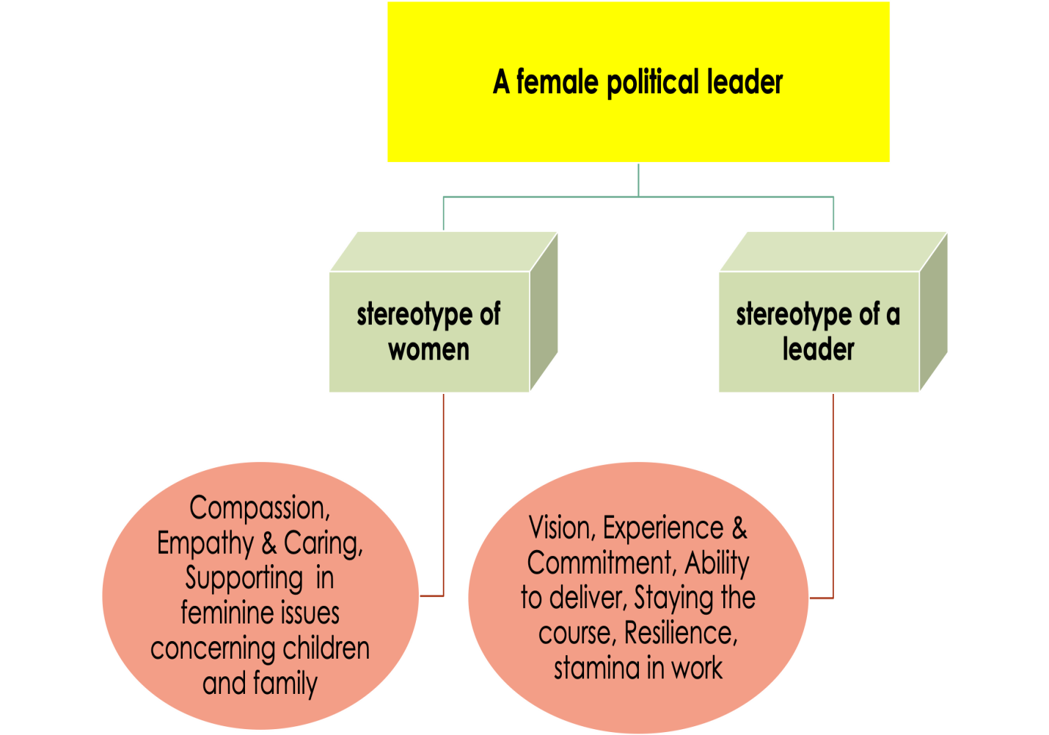

Figure 3.4 Duality in Hillary Clinton's depiction
This study analyzes the three speeches given in 2016, and I think I am fortunate enough to have an opportunity to critically look at the effect of those discourses four year later. The fact of the matter is Hillary lost to Donald Trump, and questions about the failure of the three speakers’ power (to persuade to voters to elect Hillary Clinton), and their ideologies (the images and qualities that they constructed in their discourses) were raised: Why did she lose? There could have been a number of reasons behind her defeat. One of them probably is the suggestion that her loss was due to the fact that Hillary and the Establishment were out of touch with mainstream America. The other factors at work could be the staggering inequality, racism, that were staring inside American society and confronting Americans. Many of them felt they were left behind. From the perspective of CDA, it is assumed that individuals more often than not exercise their power through ideology to persuade (in this case), or to effect change. But there has been no guarantee that their power and ideology would work, at least in this case. Thus, it is possible to see that the power and ideology does not always lead to change. Another relevant point is that discourse as social practice may have its limits: that is the limit of the power of discourse or language. The success of social practices lies in the combination and contribution of other social, personal factors apart from the language. However, though Clinton’s loss implies the continued association of men with executive office in America, the perceptions of presidencies and prime-ministerships being synonymous with men may be challenged by a woman as is exemplified in Hillary Clinton trying to make strides into this male – dominated domain with some success (of her winning the popular votes). The image of her portrayed in the presidential run – 2016, and the reality that she won the popular votes suggest and signals the fact that there may have been changes in social perceptions and recognitions of women in the political sphere and though the hardest of glass ceilings still remains impenetrable, it is not intact
CHAPTER 6: CONCLUSION
6.1. Recapitulation of key findings
First, it should be noted that the current study takes a different direction looking at discursive image construction of a female presidential candidate by others against the backdrop of great deal of research focusing squarely on self-representations or self-identity construction.
Addressing the first two research questions, three different images of Hillary Rodham Clinton having been constructed by the then-First Lady of the country, the then-president of the country and lastly by her husband. First, it is the image of a children’s protector and defender who has compassion for children, empathy, openness, trust and empowerment to create the betterment and wellbeing for children, especially children of disadvantages. Second, the image of a fulltime working married woman – a normal human being experiencing a normal life as we always do, from relaxation, to being a great mother to children, to a devoted and supportive wife while being independent - the quality of a modern woman in the present world is casted. Third is the image of a viable presidential candidate who has ample aptitudes and qualities that people admire, who possesses an optimistic vision of the country and country’s future and core values, who is a leader with real plans to deal with people’s concerns, helping solve their worries and problems; who is genuine (being real) to be able to cope with and make real positive changes in a complicated world where making a real change is a hard job, who is a resilient fighter who has grit in her character, always being ready, fighting for and staying attached to her core values of serving the nation and the people over challenges or changes. These characteristics of her in this image are lined up with others qualities as experience and commitment with lifetime records of devoting to the nation, stamina and the ability of ‘staying the course’ and ‘the ability to deliver’, expressing her willingness to go to any length to achieve the tasks of bringing benefits to others in whatever position she takes up
Though all three images being casted for Hillary Clinton are found in the three discourses, each speaker opts for their own choice some of her outstanding qualities/identities to make more prominent, with Michelle Obama focusing more on Hillary’s image as a fighter and protector of children, Barack Obama concentrating on her image of a devoted public servant attaching to the nation’s core values and beliefs, and Bill Clinton destining his speech for portraying her image as a real person, a human being who is genuine and actually does real positive changes to lives of people including her family. And all the images converge together to advocate her as being fit to be in the position of President. Also, each speaker opted for their own way of depicting Hillary Clinton to the public and they embedded in their discourse a different message on a woman in politics. It is crystal clear that social reality as parts of our MR mediates between discourse and society, which are in a dialectical relationship.
The analysis of the use of linguistic resources and strategies shows that all these three speakers have at their disposal a wealth of repertoires. Their prominent linguistic resources and strategies are: the careful word choice, the use of metaphor, the use of material processes, the parallel structure, the rhetoric of comparison and contrast, the rhetoric of symmetric way of writing, the use of facts, famous and influential figures and the rhetoric of maximizing her strengths while barely mentioning her weakness.
This study provides further evidence of the dialectical but indirect relationship between discourse and society or social structures. Discourses are formed and operate under the constraint of social factors; but on the other hand, societal practices and social structures are affected by discourses to some extent. However, it is by far and away a direct relation. It should be seen that in this kind of indirect rapport, MR (member resources) plays an essential role. The three speakers must have enacted their power and activated their MR. Their ideologies, in this study, refer to Hillary’s images and the messages about her.
The current study highlights the role of social context as part of our MR in CDA, and how our MR is activated and deployed in critical studies. In this sense, it contributes to how our knowledge of the social context and social practices determines the workings of discourse as it offers an answer to the third research question of why such images and qualities were constructed.
6.2. Implications
6.2.1 Implications for theory and research
Theoretically and methodologically, the study highlights the usefulness of CDA, and especially the dialectical-relational approach in analyzing social practices, and the relationship between discourse and society. We need to avoid falling into the dilemma of either theory for its own sake or seeing method as theory-free means of achieving results (Bourdieu and Wacquant (1992) in Chouliaraki and Fairclough, 1999). It can help to rebut some of the criticisms against CDA. It is one of the few studies devoted to female politician image construction by others.
6.2.2 Implications for practice
Pedagogically, this study contributes to awareness of the role language played in sustaining or transforming social structures. Our linguistic repertoires help us express meanings and ideologies critically. As such it can offer pedagogical implications, raise critical language awareness, and lead people in the direction of social change.
6.3. Limitations and suggestions for further research avenues
Limitations of the study
This study has certain limitations some of which may be said to be inherent in CDA work. First, the analysis undertaken here is more focused on discourse interpretation from the analyst’s perspectives than the other part of the interaction equation, that is discourse production. Another limitation is my research did not adequately address the issue of reader response and audience reception (Breeze, 2011). The question is how the discourse analysts’ interpretation of text can or should match with readers’ comprehension, and audience reception, of text. As a matter of fact, this work would be way beyond the scope of this study. Finally, it is the issue of making sense of discourse: how our MR is activated to produce interpretations or readings of the text. I relied on what Talmy posits about this, that is the workings of introspection. Perhaps, we have to wait for advances in cognitive sciences to get answers.
Suggestion for further research
This study concerns the other-construction supporters of a female presidential candidate, it would be exciting to conduct another study concerning other-construction by the haters or enemies of the same candidate. The bottom-line is to see whether these opposite forces would use the same discursive resources and strategies or not to construct the candidate. Another line of research would be to see how this same female presidential candidate is discursively represented or constructed in the media of different countries.

THESIS-RELATED PUBLICATIONS

Journal articles:
1. Trần Thị Vân Thuỳ (2015). Power Relation Negotiation between Writers and Readers Embedded in Some CNN Commentaries. Journal of Science: Foreign Studies, Vol.31, No 4 (2015) 61-71
Conference proceedings:
1. Trần Thị Vân Thuỳ (2017). How is the issue of women’s empowerment illustrated in opinion pieces in two different cultures. Proceeding of ‘2017 Graduate Research Symposium’, ULIS-VNU, 593-603
2. Trần Thị Vân Thuỳ (2018). American political discourse – arguing for the importance of the female role model in the White House: A CDA approach. 2018 International Graduate Rresearch Symposium Proceedings, ULIS-VNU, 653-667
3. Trần Thị Vân Thuỳ (2019). A revision of Critical Discourse Analysis and its major approaches. 2019 International Graduate Rresearch Symposium Proceedings, ULIS-VNU, 779-790
4. Trần Thị Vân Thuỳ (2020). Discursive images of a female presidential candidate constructed in some American political discourses – A CDA approach. 2020 International Graduate Rresearch Symposium and 10th East Asia Chinese teaching forum, ULIS-VNU, 121-138

The NBC News|SurveyMonkey Weekly Election Tracking poll was conducted online July 25 through July 31, 2016 among a national sample of 12,742 adults who say they are registered to vote. Respondents for this non-probability survey were selected from the nearly three million people who take surveys on the Survey Monkey platform each day. Results have an error estimate of plus or minus 1.2 percentage points.

