VIETNAM NATIONAL UNIVERSITY, HANOI
UNIVERSITY OF LANGUAGES & INTERNATIONAL STUDIES
--------------------------------------

TRẦN THỊ YẾN

SOCIAL EMOTIONAL LEARNING:
AN EXPLORATORY STUDY OF PRE-SERVICE EFL TEACHERS’ PERCEPTIONS AND PRACTICES AT A PEDAGOGICAL UNIVERSITY IN VIETNAM

Major: English Language Teaching Methodology
Code: 9140111

SUMMARY OF DOCTORAL THESIS

Hanoi - 2025
The thesis has been conducted at
University of Languages and International Studies, VNU

Supervisors:
1. Assoc.Prof.Dr. Nguyễn Thị Mai Hương
2. Dr. Huỳnh Anh Tuấn

Reviewer 1: …………………………………………
Reviewer 2: …………………………………………
Reviewer 3: …………………………………………

The thesis will be defended before the Doctoral Thesis Evaluation Committee at University of Languages and International Studies, VNU
at ………, on ………………………, 2025.

The thesis can be accessed at:
- The National Library of Vietnam
- The Information and Library Center, Vietnam National University, Hanoi.

CHAPTER I: INTRODUCTION

1.1. Rationale for the study
The growing demands of 21st-century education have exposed the limitations of traditional approaches that overemphasize academic achievement while neglecting social emotional competencies (SECs), which are also important for students’ holistic development (Kautz et al., 2014). Many countries have integrated Social Emotional Learning (SEL) into teacher education and school practices, but in Vietnam, SEL remains implicit and inconsistent (Tran & Le, 2023). Despite recent reforms promoting holistic education (MOET, 2018), SEL is not systematically embedded in teacher training, leaving many pre-service teachers underprepared for the social-emotional demands of teaching (Tran & Le, 2023). This situation is especially concerning in EFL education contexts, which require strong socio-emotional support (Dewaele et al., 2022). However, Vietnamese EFL teacher education has not adequately addressed SEL yet. Therefore, this study investigates how SEL is perceived, practiced and supported in a Vietnamese EFL teacher education program, aiming to inform more comprehensive and responsive teacher preparation aligned with national education goals.

1.2. Research aim, objectives and questions
The primary aim of this research is to investigate how pre-service EFL teachers perceive and practise Social Emotional Learning (SEL) within their professional learning at a teacher training institution in Vietnam.
To achieve this aim, this study is guided by the following objectives:
- To explore how SEL is integrated into the EFL teacher education program.
- To explore how pre-service EFL teachers perceive SEL.
- To explore how pre-service EFL teachers practise SEL in their professional learning.
This study aims to answer the following research questions (RQ):
RQ1. How is SEL integrated into the EFL teacher education program?
RQ2. How do pre-service EFL teachers perceive SEL?
RQ3. How do they practise SEL within their professional learning?
These three research questions are closely interrelated, forming a progression of exploration from training to perceptions and actual practices of SEL among pre-service EFL teachers.

1.3. Scope of the study
This study focuses on SEL within the EFL teacher education program at a pedagogical university in Vietnam during the academic year 2023–2024. It examines three core aspects: (1) how SEL is integrated into the program; (2) pre-service EFL teachers’ perceptions of SEL, including their familiarity, perceived benefits, challenges and preparedness; and (3) how they practise SEL in terms of SECs and SEL instructional competence. The study targets pre-service EFL teachers, with supplementary data from trainers to gain a more comprehensive picture.

1.4. Significance of the study
This thesis makes significant contributions to EFL teacher education. By identifying strengths and gaps in pre-service teachers’ SEL training, perceptions and practices, it offers concrete recommendations for curriculum reform, teacher professional development, policy adjustment and future research. A localized SEL framework, comprising five core SECs and five components of SEL instructional competence, was developed to guide context-specific training and practice. Additionally, two data collection instruments (an observation sheet and a questionnaire) were designed and validated to assess SEL training, perceptions and practices. These contributions offer clear theoretical basis, empirical evidence and practical instruments to promote SEL implementation and holistic education for students.

1.5. Structure of the thesis
This thesis is structured into seven chapters: Introduction, Literature Review, Research Methodology, Training in SEL, Perceptions of SEL, Practices in SEL, and finally Discussion and Conclusion.

CHAPTER II: LITERATURE REVIEW
Chapter II reviews major theories and studies on SEL to support its integration into Vietnamese EFL teacher education. It presents SEL as a holistic approach to learning, outlines core concepts and competencies, and examines teachers’ perceptions, practices and training. The chapter also reviews SEL implementation globally, highlighting gaps in training and application, especially in non-Western contexts like Vietnam.

2.1. Prevalent views of learning
Research shows that learning is influenced by both cultural traditions and educational theories. In Vietnam and other Confucian Heritage Culture (CHC) countries, learning often emphasizes respect for authority and academic success, which can limit student creativity and autonomy (Nguyen et al., 2006). Theories like behaviorism, constructivism and social learning explain how students learn through rewards, interaction and experience (Bandura, 1977; Piaget, 1952; Vygotsky, 1978). Emotional and social skills are also important in the learning process, as highlighted in theories of multiple intelligences and emotional intelligence (Gardner, 1983; Goleman, 1995). SEL fits well with these prevalent views of learning. Previous studies show SEL helps students grow emotionally and socially while supporting academic success (Durlak et al., 2011).

2.2. The understanding of SEL
SEL was first conceptualized by CASEL in 1994 and defined as the process through which individuals develop skills to manage emotions, build relationships and make responsible decisions (CASEL, 2020). SEL is often confused with overlapping terms like life skills and character education, causing inconsistencies in research and practice (Farrington et al., 2012). CASEL’s five core competencies offer a clear framework to address this confusion. Scholars such as Pentón Herrera (2022) and Markowitz et al. (2016) emphasize SEL as both a developmental process and a lens through which teaching and learning occur. This study adopts this perspective, positioning SEL not merely as a set of skills but as a holistic approach embedded in all aspects of education.

2.3. Social emotional competencies

2.3.1. Interpretations of the five core SECs
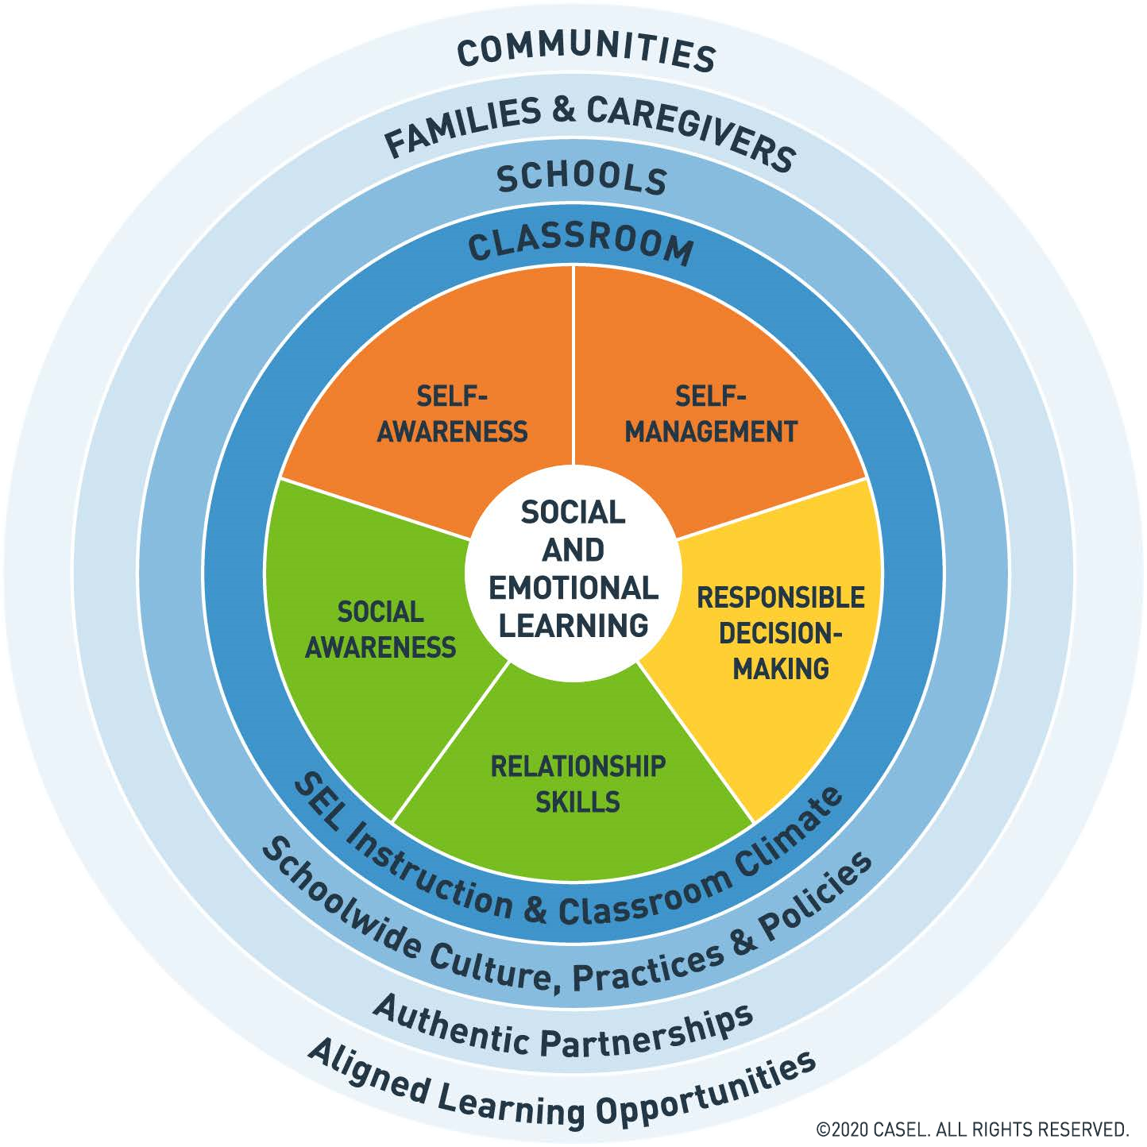
Social emotional competence can be defined as “the ability to understand, manage and express the social and emotional aspects of one’s life in ways that enable the successful management of life tasks such as learning, forming relationships, solving everyday problems and adapting to the complex demands of growth and development (Elias et al.,1997, p. 2). CASEL (2020) outlines the five core SECs, namely self-awareness, self-management, social awareness, relationship skills and responsible decision-making. Each competence comprises specific skills that contribute to both social and emotional growth.
Figure 1. CASEL’s 2020 framework for systemic SEL

2.3.2. Teachers’ SECs and SEL instructional competence
Teachers’ SECs are essential for effective teaching and positive student outcomes (Jennings & Greenberg, 2009). However, teacher education programs often prioritize content and pedagogy over explicit training in SECs (Waajid et al., 2013). SEL instructional competence is also recognized as essential for teachers to effectively support students’ SECs. Scholars such as Huynh et al. (2022), Phan (2021), and Jennings & Greenberg (2009) emphasize different dimensions of this competence. Based on their perspectives, this study proposes five components of SEL instructional competence as can be seen in Figure 2.
Figure 2. Components of SEL instructional competence
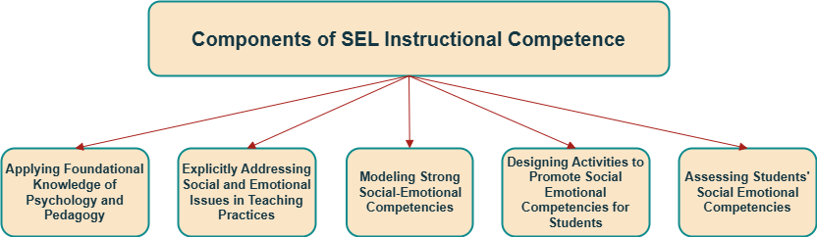

2.4. Teachers’ perceptions, practices and training in SEL
The literature primarily focuses on examining SEL in relation to students; however, it is important to look at SEL from teachers’ perspectives (Jennings et al., 2017). Teachers are those who directly implement SEL in the classroom; therefore, their perceptions, practices and training directly influence its implementation.

2.4.1. Teachers’ perceptions of SEL
Teachers’ perceptions significantly influence the implementation of SEL. Many teachers acknowledge SEL's positive impacts on students’ social, emotional and academic growth (Mahoney et al., 2018); however, studies reveal a widespread lack of clarity regarding SEL terminology and strategies (Buchanan et al., 2009). Teachers also play important roles in SEL implementation, but not all fully recognize this responsibility (Jennings & Greenberg, 2009; Zhou & Ee, 2012).

2.4.3. Teachers’ practices in SEL
Teachers promote students’ SECs through both explicit and implicit (CASEL, 2020) instruction. SEL practices include student-centered discipline, positive teacher language, responsibility and choice, warmth and support, cooperative learning, meaningful classroom discussions, self-assessment and reflection, balanced instruction, high academic expectations and SEL competence building (Yoder, 2014).

2.4.4. Teachers’ training in SEL
Despite their important roles in SEL implementation, many teachers feel unprepared due to limited training in both pre-service and in-service programs (Schonert-Reichl, 2017). SEL is often underrepresented or embedded within general courses like teaching theories and methodology or classroom management (Katz et al., 2020). Therefore, teacher training programs should strengthen teachers’ own SECs and instructional competence (Greenberg et al., 2017).

2.5. Theoretical and conceptual frameworks
To guide this study, three theoretical frameworks are adopted. First, CASEL’s 2020 Framework for Systemic SEL (see Figure 1) offers a clear, evidence-based model centered on five core SECs and emphasizes coordinated efforts across classrooms, schools, families and communities (Durlak et al., 2011). Second, the study adopted Jennings and Greenberg’s (2009) Prosocial Classroom Model, which emphasizes how teachers’ SECs impact SEL implementation. In addition, Lawlor’s (2016) Framework for Promoting the Prosocial Classroom in Educator Preparation was adopted as it stresses the need to develop pedagogical skills and SECs for teachers, aligning with this study’s focus.
The conceptual framework of the current study integrates three interrelated components: pre-service EFL teachers’ perceptions, practices and training in SEL, grounded in international, national and institutional contexts. These components are interconnected, with training influencing both perceptions and practices, while perceptions and practices also influence each other.
Figure 7. The conceptual framework of the current study
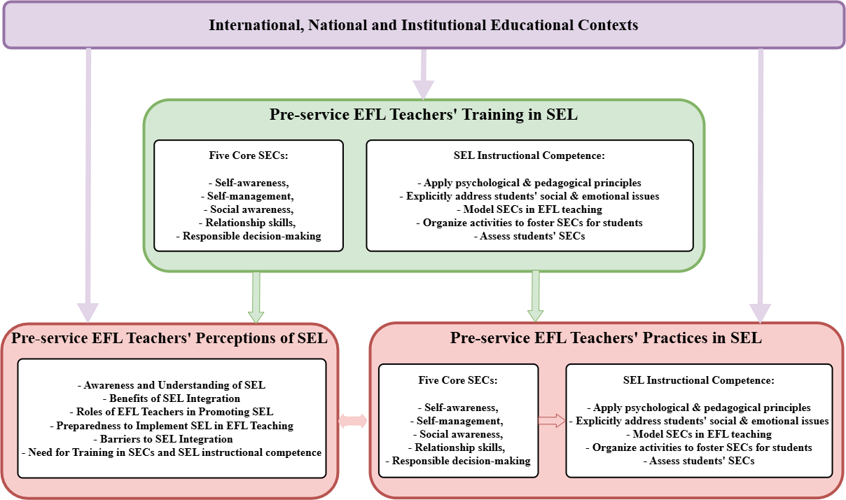

CHAPTER III: RESEARCH METHODOLOGY
This chapter presents and justifies the study’s research methodology. The study adopts a pragmatic philosophy, an abductive approach and an exploratory sequential mixed-methods design. The chapter also details the use of various data collection methods, the research context, participants and data analysis procedures.

3.1. Research context and participants
This study was conducted at a pedagogical university in Vietnam (VPU), which was selected for its well-established EFL teacher education program and the researcher’s long-term professional affiliation. The study involves 380 pre-service EFL teachers and 18 teacher trainers.

3.2. Exploratory sequential mixed-methods research design
Figure 11. Exploratory sequential mixed methods research design
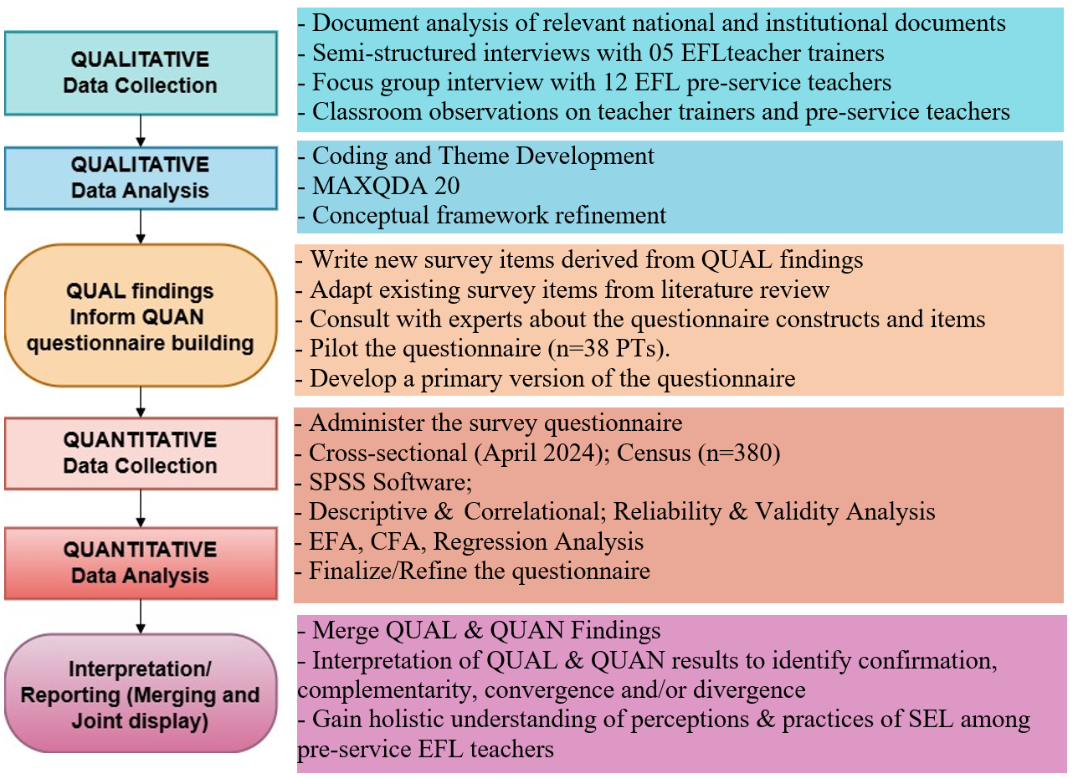
This study employed an exploratory sequential mixed-methods design. It began with qualitative methods to explore the under-researched phenomenon of SEL in EFL teacher education in Vietnam. Findings from this phase informed the development of a contextualized questionnaire, which was then administered to all 380 pre-service teachers of VPU. This design allowed for the validation and expansion of qualitative findings through quantitative data, enabling triangulation and offering a comprehensive understanding of SEL perceptions and practices among pre-service EFL teachers at VPU.

3.3. Data collection instruments and data analysis techniques
3.3.1. Document analysis
The first phase analyzed the Vietnamese General Education Curriculum (2018) and VPU’s EFL teacher training curriculum (2022) to identify SEL elements based on the CASEL framework. Coding was conducted in MAXQDA. The findings informed the study's SEL framework and subsequent data collection instruments.
3.3.2. Semi-structured interviews with EFL teacher trainers
Five EFL teacher trainers were purposively selected for interviews to explore their perceptions and practices related to SEL training. The interview protocol (30 open-ended questions) was informed by the research objectives, existing instruments and refined through expert feedback. Interviews were thematically analyzed using Braun and Clarke’s (2006) six-phase framework for thematic analysis.
3.3.3. Focus group interview with pre-service EFL teachers
A focus group with 13 pre-service EFL teachers was also conducted to explore their perceptions, practices and training in SEL. Conducted in April 2024, the three-hour discussion session followed a semi-structured, piloted guide.
3.3.4. Classroom observations
Observations of trainers and pre-service teachers examined SEL training and practices in real classrooms using a structured, context-adapted observation sheet.
3.3.5. Questionnaire for pre-service EFL teachers
A 37-item bilingual questionnaire was developed from prior qualitative findings and instruments to assess SEL perceptions, practices and training. Piloted with 38 graduates, it was administered to 380 participants (92.37% response rate) in May 2024. Data were analyzed via SPSS and AMOS using descriptive stats, ANOVA, EFA, CFA, correlation and regression analysis.

CHAPTER IV: EFL PRE-SERVICE TEACHERS’ TRAINING IN SOCIAL EMOTIONAL LEARNING
Chapter IV examines how SEL is embedded in the EFL teacher education program of VPU. It analyzes teacher trainers’ perspectives; the five core SECs and components of SEL instructional competence in the national and institutional curricula; and the strategies for developing these competencies. The findings provide essential context for understanding pre-service teachers’ SEL perceptions and practices presented in later chapters.

4.1. EFL teacher trainers' perspectives on SEL training
EFL teacher trainers at VPU valued SEL, though many were unfamiliar with the formal term. They intuitively implemented SEL through learning activities like group work, and emphasized its alignment with Vietnamese cultural and education values. Trainers highlighted the lack of explicit SEL training and identified barriers such as limited time, resources and institutional support. They recommended structured workshops, stakeholder engagement and integration of SEL into coursework and assessments.

4.2. Elements of SEL addressed in the curricula

4.2.1. Specific social emotional skills addressed in the curricula
Document analysis reveals the uneven presence of the five core SECs in Vietnam’s 2018 General Education Curriculum and the EFL teacher training curriculum of VPU. Self-management is most emphasized in both curricula, while Self-awareness is least addressed. The remaining competencies, Social awareness, Relationship skill, and Responsible decision-making, are moderately represented. In general, the EFL teacher training curriculum of VPU aligns with the national priorities regarding the integration of SECs.

4.2.2. Components of SEL instructional competence addressed in the curriculum
Analysis of the EFL teacher training curriculum at VPU also shows uneven emphasis across the five components of SEL Instructional Competence. The strongest focus is on applying psychological and pedagogical knowledge and modeling SECs in teaching, while designing SEL activities receives moderate attention. In contrast, explicit use of SEL concepts and assessment of students’ SECs are minimally addressed.
Figure 18. Components of SEL instructional competence in the curriculum
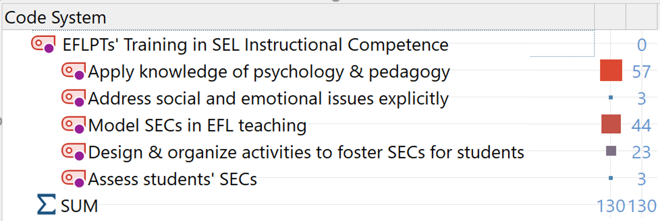

4.2.3. Developing a framework of SEL for pre-service EFL teachers
The development of a comprehensive framework, combining five core SECs and an additional domain, SEL instructional competence, represents an important step in defining the essential SEL skills for pre-service EFL teachers. It was grounded in the CASEL framework and adapted to the Vietnamese educational context. The framework outlines the competencies needed for both personal SECs and effective SEL integration in teaching. It also served as the basis for designing the study’s classroom observation sheet and questionnaire, enabling a structured investigation of how pre-service teachers perceive and practise SEL in their professional learning.
EFA and CFA results confirmed the reliability of the framework. EFA identified six valid components with strong loadings, explaining 55.56% of the variance. CFA showed a good model fit (e.g., RMSEA = 0.053, CFI = 0.888), validating the framework’s structure for use in EFL teacher education.

4.3. Pre-service EFL teachers' training in SECs
The evaluation of SECs training for pre-service EFL teachers reveals three main issues: excessive focus on language skills, inconsistent instructor approaches to SEL, and uneven attention across SECs. The curricula emphasize self-management and relationship skills, but self-awareness, social awareness and responsible decision-making receive less focus. However, pre-service teachers feel more trained in relationship skills and self-awareness than in self-management, indicating a clear misalignment between intended, implemented and perceived training. Although trainers employ diverse strategies like group work and reflective activities, more consistent and balanced integration of SECs is needed.

4.4. Pre-service teachers' training in SEL instructional competence
Training in SEL instructional competence for pre-service EFL teachers is generally moderate and mostly implicit. Components like applying pedagogical knowledge, modeling SECs and designing SEL-related activities are moderately addressed, meanwhile components such as explicit use of SEL concepts and assessing students’ SECs receive little attention. Quantitative data reflect this imbalance, with the highest rating for pedagogical knowledge (Mean = 3.82) and the lowest for assessment (Mean = 2.94). Trainers use methods like reflective tasks, scenario-based learning and group projects to build SEL instructional competence for pre-service teachers, yet the lack of training in explicit SEL instruction and assessment indicate a need for clearer, more consistent and intentional SEL training.

Chapter Summary
Chapter IV analyzed how SEL is integrated into EFL teacher education by examining teacher trainers’ perspectives, curriculum content and training strategies. Although SEL is present in the curriculum, it is often implicit, unevenly distributed and inconsistently implemented. Similarly, training in SEL instructional competence focuses more on applying pedagogical knowledge, modeling SECs and designing SEL activities, while explicit SEL instruction and assessment receive little attention. Variability in trainers’ practices further contributes to pre-service teachers’ inconsistent training experiences. These findings indicate the need for a more explicit, cohesive and balanced approach to SEL in EFL teacher education.

CHAPTER V: PRE-SERVICE EFL TEACHERS' PERCEPTIONS OF SOCIAL EMOTIONAL LEARNING
This chapter explores pre-service EFL teachers’ perceptions of SEL, including their understanding, perceived benefits, role of teachers, training needs, readiness, challenges and support required.

5.1. Pre-service EFL teachers’ understanding of SEL
Pre-service EFL teachers reported a limited understanding of SEL. Although most were unfamiliar with the term initially, they gradually recognized SEL elements in their coursework, though their knowledge remains surface-level due to a lack of explicit training. Focus group data revealed varied and sometimes confused interpretations of SEL. While they understood self-awareness and self-management fairly well, their understanding of social awareness, relationship skills and responsible decision-making was less accurate and lacked depth. Questionnaire results confirmed moderate knowledge of SEL but limited understanding of teaching and assessing methods for SEL (see Table 16). These findings point to the need for explicit SEL instruction in teacher education.
Table 16. Pre-service EFL teachers' knowledge of SEL
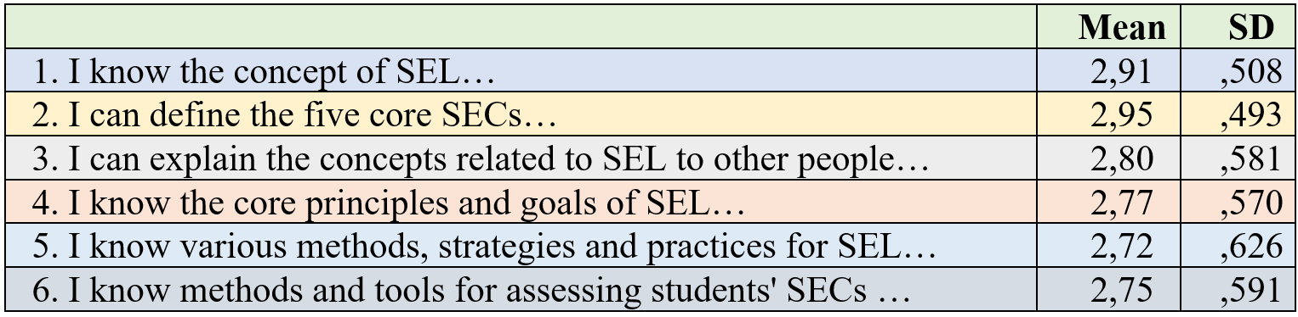

5.2. Perceived benefits of SEL
Pre-service EFL teachers consider SEL highly beneficial for their personal, academic and professional growth. They believe SEL fosters self-awareness, goal-setting, emotional well-being, stronger classroom relationships, student engagement and real-life readiness. These views were confirmed by questionnaire data, with consistently high mean scores for all the identified benefits (M = 3.81–4.21).

5.3. Perceived roles of EFL teachers in promoting SEL
Pre-service EFL teachers see themselves as key figures in promoting SEL. They view their roles as not only instructional but also as facilitators, role models and “second parents” who support students’ holistic development. They believe SECs are teachable and can be integrated into language lessons. EFL is considered well-suited for SEL due to its emphasis on communication and intercultural understanding. Quantitative data supports these views, with high ratings for the teacher’s role in fostering all the five core SECs for students, with the highest rating for self-management (M = 4.07). These perceptions are very positive, reinforcing the alignment between SEL and current student-centered, competency-based educational reforms.

5.4. Perceived preparedness for SEL
Pre-service EFL teachers feel moderately prepared to implement SEL. They feel relatively prepared in designing SEL activities (M = 3.62), applying pedagogy (M = 3.54), and modeling SECs (M = 3.50). However, they feel less confident in applying SEL concepts explicitly and assessing students' SECs, both rated lowest (M = 2.98). It can be seen that although they have strong personal SECs, they feel underprepared to implement SEL in their teaching practices to foster SECs for their students. Trainers also noted these concerns and emphasized the need for more training in explicit SEL theories and in assessment strategies to ensure that pre-service EFL teachers are fully prepared to integrate SEL into their EFL teaching practices.

5.5. Perceived barriers to the implementation of SEL
Pre-service EFL teachers face multiple barriers to SEL implementation, including lack of training, time constraints, limited resources and low student engagement. Quantitative data confirms training gaps (M=3.70), time pressures (M=3.66) and resource shortages (M=3.68) as top challenges. These findings indicate the need for explicit SEL training, practical tools and institutional support to facilitate effective SEL integration in EFL classrooms.

5.6. Perceived need for training in SEL
Pre-service teachers strongly recognize the need for explicit, practical training in SEL to support their future teaching. They emphasized the need for more engaging and structured training in SECs and called for SECs to be better integrated across courses. They also felt unprepared to teach SEL due to vague or implicit training. Practical, hands-on strategies were seen as essential to apply SEL in real classrooms. Quantitative data confirm this need, with high scores for all SECs (3.75–3.88) and the highest for SEL instructional competence (3.91).

5.7. Recommendations for enhancing SEL in teacher education
Pre-service EFL teachers strongly recommended enhancing SEL integration in teacher education through clearer, more explicit instruction; the introduction of dedicated or integrated SEL courses; and early exposure to SEL content from the first year of training. They emphasized the importance of making SEL courses mandatory or better oriented to increase awareness and engagement, and stressed the need for accessible, high-quality resources adapted for the EFL instruction.

Chapter Summary
Chapter V examined pre-service EFL teachers’ perceptions of SEL, revealing generally positive attitudes and a recognition of SEL’s value for personal, academic and professional growth. Although many pre-service teachers demonstrated intuitive understanding of SEL elements, their knowledge often lacked depth, coherence and grounding in formal frameworks. They viewed EFL teachers as responsible for both language instruction and fostering students’ SECs, but they felt underprepared due to the lack of explicit training. Major barriers identified include lack of SEL training, time constraints and insufficient resources. To address these issues, pre-service teachers called for more explicit, structured and early integration of SEL into their training programs.

CHAPTER VI: PRE-SERVICE EFL TEACHERS' PRACTICES IN SOCIAL EMOTIONAL LEARNING
Chapter VI moves from perceptions to actual practices in SEL. It first examines how pre-service EFL teachers demonstrated the five core social emotional competencies (SECs) in their role as learners, followed by a focus on how they demonstrated SEL instructional competence in their role as teachers.

6.1. Pre-service EFL teachers’ practices in SECs
Pre-service EFL teachers generally demonstrated moderate-to-high levels of SECs, but not at an outstanding level. Teacher trainers described their SECs as “slightly above average” or “good,” with notable variation across individuals. Quantitative data support this, with mean scores ranging from 3.45 (self-management) to 3.83 (social awareness), indicating the highest proficiency in social awareness and the lowest in self-management. In general, pre-service EFL teachers demonstrated moderate-to-high levels of SECs, but inconsistencies across skills and individuals, indicating the need for more targeted training.
Table 22. Pre-service EFL teachers’ practices in SECs
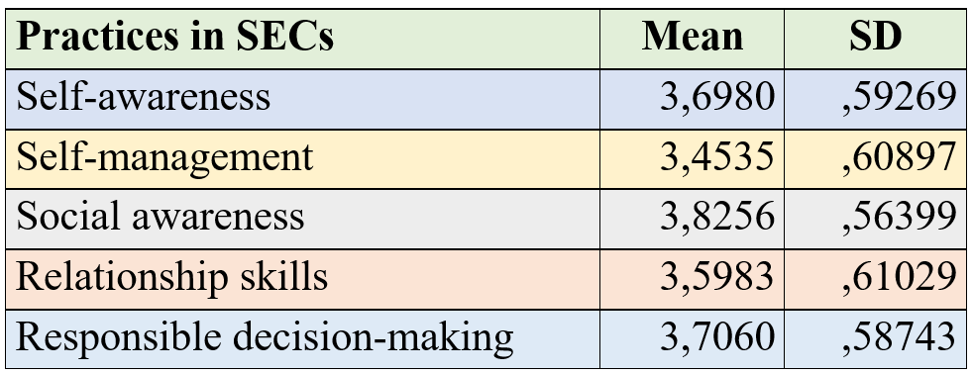

6.2. Pre-service teachers’ practices in SEL instructional competence
Pre-service EFL teachers demonstrate moderate levels of SEL instructional competence (M = 3.34), but their practices are often informal, intuitive and inconsistent due to the lack of systematic training and assessment in the curriculum. While they showed proficiency in general pedagogy (M = 3.66) and organizing SEL-related activities (M = 3.75), challenges remain in explicitly using SEL concepts (M = 2.96) and assessing students' SECs (M = 2.79). These findings point to the need for more structured, balanced and explicit training in SEL instructional competence.
Table 28. Self-reported proficiency in SEL instructional competence
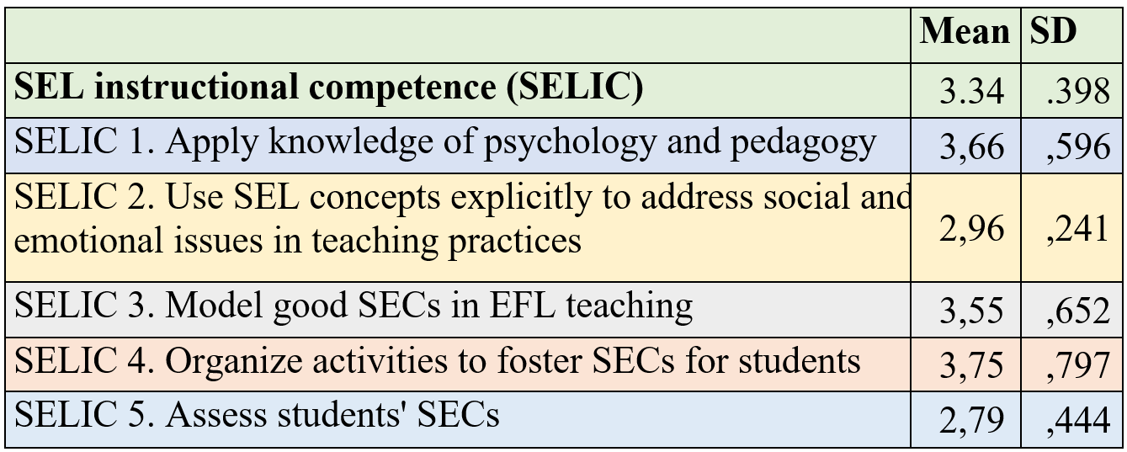

6.3. ANOVA, correlation and regression analysis
This section focuses on exploring the correlations between pre-service EFL teachers' perceptions, practices and training in SEL. Additionally, regression analysis is conducted to identify key predictors of SEL practices, or how various factors such as training and perceptions influence the practices of SEL among pre-service EFL teachers.

6.3.1. Variations in SEL practices among pre-service EFL teachers
Data reveal significant variations in SEL practices among pre-service EFL teachers. While some showed strong SECs and SEL instructional competence, others did not demonstrate these competencies well. Stronger SECs, especially in self-management and responsibility, correlate with better academic performance. Although gender shows no major impact on SECs, difference was found in SEL instructional competence. Training year impacts some SECs, like self-management, relationship skills and decision-making, but not self-awareness, social awareness or SEL instructional competence. These variations indicate the need for more explicit, consistent and balanced SEL training throughout the program.

6.3.2. Correlations among SECs and SEL instructional competence
Data reveal strong correlations among the five core SECs, especially between self-awareness and self-management (r = .556), confirming their interdependent nature. However, the correlation between overall SECs and SEL instructional competence is moderate (r = .342), with relationship skills showing the highest link (r = .319) and self-management the lowest (r = .193). This suggests SECs alone are insufficient for effective SEL teaching. Many pre-service teachers, though having good SECs, could not implement SEL effectively in teaching practices. SEL instructional competence thus requires not just personal SECs but also other knowledge and skills such as SEL theories, organizing SEL activities and assessing students’ SECs.

6.3.3. Comparisons of scores across perceptions, practices & training
Pre-service EFL teachers reported positive perceptions of SEL (M = 3.96), but their actual practices in SECs (M = 3.67) and SEL instructional competence (M = 3.34) were lower. These scores reveal a gap between what they value and what they can implement.
Table 32. Comparison of scores across perceptions, practices & training
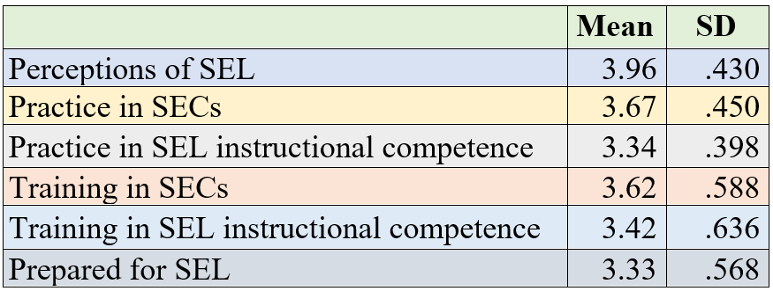
They showed stronger personal SECs than instructional competence, indicating they are better at their own SECs than teaching SECs to students. Training data reflect the same pattern: more emphasis on developing personal SECs (M = 3.62) than training for teaching SEL (M = 3.42). Preparedness for SEL was even lower (M = 3.33), with high variability, suggesting many still feel underprepared. In short, while pre-service teachers value SEL and possess good SECs, they need structured training to teach SEL effectively.

6.3.4. Correlations among perceptions, practices and training
Pre-service EFL teachers’ perceptions of SEL moderately correlate with training (r = .478) and practices (r = .437), suggesting that those who value SEL are more likely to engage in training and implementing it. However, perceptions are weakly linked to preparedness (r = .201), indicating that positive beliefs alone are insufficient for feeling ready. Training strongly correlates with practices (r = .564) and moderately with preparedness (r = .326), showing its important role in shaping behavior. Practices moderately correlate with preparedness (r = .446), reinforcing the importance of hands-on application. Overall, training and practice, not just perceptions, are essential for developing competencies and preparedness.
Table 33. Correlations among SEL perceptions, practices & training
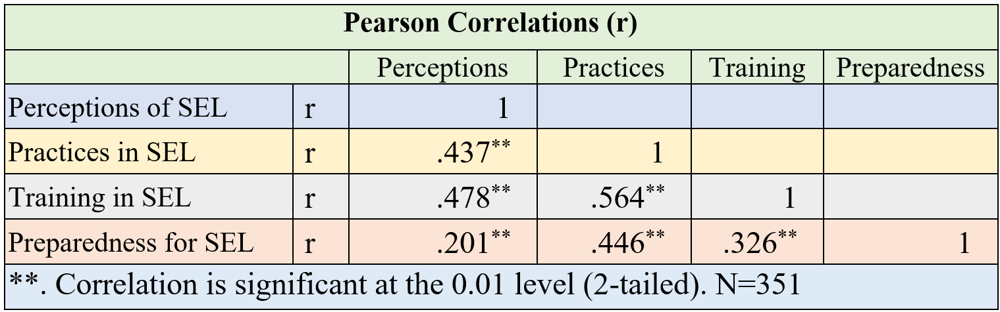

6.3.5. Regression analysis of key factors influencing practices in SEL
The regression analysis reveals that perceptions, training and preparedness significantly predict SEL practices among pre-service EFL teachers, explaining 50.6% of the variance (R = 0.711; R² = 0.506), with training having the strongest impact. The model was statistically significant (F = 16.020, p < .001) and met key assumptions of normality, linearity and homoscedasticity. The regression results affirm the importance of these factors, especially SEL training, in predicting practice. However, nearly half the variance remains unexplained, indicating a need for further research into other factors influencing SEL practices.
Table 34. Regression analysis of factors influencing SEL practices
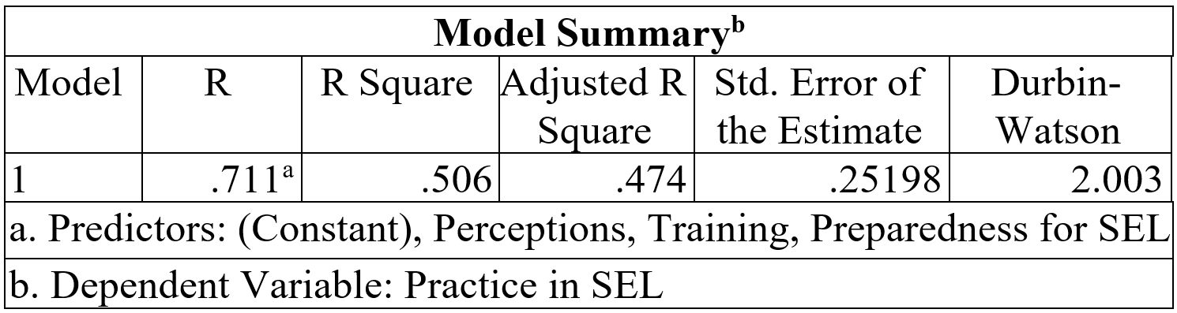
Figure 22. Histogram 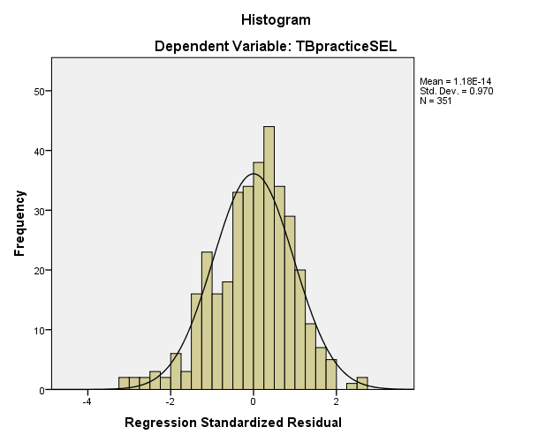 | Figure 23. Normal P-P Plot  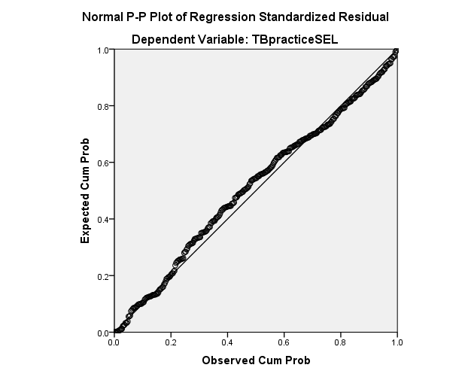

Chapter Summary
Chapter VI examines pre-service EFL teachers’ SEL practices, focusing on their SECs and SEL instructional competence. SECs were rated above average, with social awareness rated highest and self-management lowest. SECs improved slightly over training years and were positively linked to academic performance, though gender showed no effect. Regarding SEL instructional competence, strengths included applying pedagogical knowledge, organizing SEL activities and modelling SECs, but gaps remained in using explicit SEL language and assessing students’ SECs. Correlation and regression analyses confirm that training significantly influence SEL perceptions and practices. These findings highlight the urgent need for more explicit, structured, and practice-based SEL training in Vietnamese EFL teacher education.

CHAPTER VII: DISCUSSION AND CONCLUSION
Chapter VII summarizes and discusses the major findings on pre-service EFL teachers’ perceptions and practices of SEL at a Vietnamese pedagogical university. It connects these findings to the research questions and conceptual framework, situates them within existing literature, and contextualizes them in Vietnam’s educational and sociocultural contexts. It also offers practical recommendations for promoting SEL in teacher education, acknowledges methodological limitations, and outlines directions for future research.

7.1. Summary of the main findings
The thesis yields several important new findings that advance the understanding and implementation of SEL in Vietnamese EFL teacher education.
First, the study reveals that elements of SEL are present in the EFL teacher education curriculum but are predominantly implicit, uneven and inconsistent. Among the five core SECs, greater emphasis is placed on self-management, relationship skills and responsible decision-making, while self-awareness and social awareness receive less attention. Likewise, training in SEL instructional competence focuses heavily on pedagogical knowledge, modeling SECs and organizing SEL activities, but lacks emphasis on explicit SEL instruction and assessment.
Second, pre-service EFL teachers hold highly positive perceptions of SEL. They highly appreciate its multiple benefits and clearly recognize their multiple roles in fostering students’ SECs. However, their limited formal knowledge and lack of preparedness for SEL point out significant gaps in the training program. Recognizing these limitations, they strongly expressed the need for more structured, explicit SEL training to master SEL-related theories and skills to effectively implement SEL in their teaching practices.
Third, in terms of SEL practices, pre-service teachers demonstrated efforts to integrate SEL, but their practices were often intuitive, fragmented and inconsistent. Their SECs were rated as slightly above average, with social awareness scoring highest and self-management lowest. They also showed moderate-to-high proficiency in SEL instructional competence, particularly in applying pedagogical principles, organizing SEL-related activities and modeling SECs in class, but they showed limited ability to use explicit SEL concepts and to assess students’ SECs during their teaching practice..
Finally, the findings reveal the interconnectedness of SEL training, perceptions and practices, highlighting that the implicit and fragmented nature of SEL training contributes to limited formal knowledge, lack of preparedness and fragmented classroom practices. These findings emphasize the urgent need for structured, explicit and culturally responsive SEL training, thereby enhancing the quality of teacher education in the context of holistic educational reform.

7.2. Discussion of major findings

7.2.1. Alignment of SEL with Vietnamese educational & cultural values

SEL aligns well with Vietnamese cultural values. Rooted in Confucian traditions, values such as self-cultivation, propriety and benevolence resonate with SEL’s focus on self-management, empathy and social responsibility (Jamieson, 1995; CASEL, 2020). Although Confucian emphasis on hierarchy and obedience may challenge SEL principles like emotional expression and student voice (Ho & Dimmock, 2023), thoughtful adaptation can ensure effective implementation and cultural harmony. SEL also supports the 2018 General Education Curriculum’s emphasis on competencies such as critical thinking, collaboration, and social responsibility (MOET, 2018; Tran & Le, 2023), offering a strong policy foundation. In EFL instruction, SEL fits naturally with communicative approaches and textbook topics on identity, relationships and global issues. Supported by major learning theories, SEL enhances both language learning and holistic development (Vygotsky, 1978; Krashen, 1982). As technology reshapes education, SEL becomes increasingly vital for cultivating essential human skills like resilience, compassion, critical thinking and collaboration (OECD, 2024).

7.2.2. Pre-service EFL teachers' training in SEL: advocacy & challenges
Although EFL teacher trainers advocate for SEL, its integration into Vietnamese teacher education remains fragmented and largely implicit due to the absence of mandated national policies (Tran & Le, 2023; Schonert-Reichl, 2017). SEL principles are informally embedded through group work and modeling but lack structure, consistency and assessment (Yoder, 2014). Pre-service teachers often receive limited exposure to SEL, mostly through brief references in pedagogy or psychology courses, resulting in limited understanding and classroom application (Markowitz et al., 2016; Jones & Kahn, 2017). The curriculum overemphasizes self-management, aligned with Confucian values, but neglecting self-awareness and social skills (CASEL, 2020), highlighting the need for a more balanced, explicit and systematic SEL training approach.

7.2.3. Perceptions of SEL: limited formal knowledge but positive attitudes
Pre-service EFL teachers at VPU have limited formal knowledge of SEL, often confusing it with life skills and showing fragmented understanding of core elements like empathy and relationship skills—likely due to its implicit delivery in training (Huynh et al., 2022; Markowitz et al., 2016). Despite this, they expressed strong support for SEL and acknowledged its value in personal, academic and professional development, consistent with both Vietnamese values and global findings (Durlak et al., 2011; Taylor, 2002). However, many felt unprepared to apply SEL in practice, with obvious difficulties in modeling SECs, teaching SEL explicitly and assessing students’ SECs (Huynh et al., 2021). Major barriers included low student engagement, time constraints, lack of materials and limited institutional support, challenges rooted in Vietnam’s exam-oriented, teacher-centered educational system (Ho & Dimmock, 2023). It is promising that they called for structured SEL training, highlighting the need to build both SECs and SEL instructional competence. This commitment reflects a positive shift in pre-service teachers’ perceptions, creates favorable conditions for the effective integration of SEL into teacher education, and lays the foundation for SEL practices

7.2.4. Practices in SEL: moderate-to-high and uneven proficiency
Pre-service EFL teachers demonstrate uneven yet promising SEL practices. They show moderate-to-high levels of social awareness, self-awareness and responsible decision-making, aligning with Confucian values of morality and harmony (Nguyen et al., 2006; Taylor, 2002). However, gaps remain in self-management and relationship skills, hindered by cultural norms and academic stress (Tran & Le, 2023; Ho & Dimmock, 2023). Regarding SEL instructional competence, most pre-service teachers can apply pedagogical strategies, design SEL-oriented activities, model SECs, but have difficulty in using SEL concepts and assessing students’ SECs due to limited training (Jennings & Greenberg, 2009; Huynh et al., 2022). Notably, while SECs are interrelated, their link to SEL instructional competence is weak, indicating that SEL instructional competence requires structured training beyond personal SECs (Schonert-Reichl, 2017).

7.2.5. Implicit training leading to limited formal knowledge of SEL
The study shows that implicit SEL training leads to fragmented knowledge and limited preparedness among pre-service EFL teachers. Although they hold positive attitudes, their formal understanding remains limited due to the lack of explicit instruction in the training program. A moderate correlation (r = 0.478) between SEL training and perceptions suggests that structured training can foster both awareness and belief in SEL’s value. Without explicit instruction, many pre-service EFL teachers relied on intuition rather than formal frameworks when applying SEL concepts (Jennings et al., 2017). This highlights the need for explicit SEL training in teacher education programs.

7.2.6. Implicit training leading to intuitive practices in SEL
Implicit SEL training results in intuitive and inconsistent practices among pre-service EFL teachers. Activities like group work support skills such as empathy and collaboration, but these are often treated as by-products rather than intentional SEL goals (Esen-Aygun & Sahin-Taskin, 2017; Pentón Herrera, 2020). Inconsistent modeling by teacher trainers further limits SEL practice, reflecting a lack of standardized training (Jennings & Greenberg, 2009; Bandura, 1977). To move from fragmented to effective implementation, explicit SEL training with clear strategies is essential (Tran & Le, 2023).

7.2.7. Matches and mismatches between perceptions & practices of SEL
Pre-service EFL teachers expressed strong belief in the value of SEL, as reflected in interactive activities like group work that promote empathy and collaboration (CASEL, 2020; Bridgeland et al., 2013). A positive correlation (r = 0.44) suggests that positive perceptions can encourage SEL practices. However, a noticeable gap remains: while perceptions are high (M = 3.99), actual SEL practices are lower (SECs = 3.67; SEL instructional competence= 3.34), mainly due to limited training, conceptual ambiguity and curriculum pressures (Zinsser et al., 2014; Markowitz et al., 2016). As a result, practices are largely intuitive and lack pedagogical structure, highlighting the limitations of implicit training and the urgent need for structured, intentional SEL instruction in teacher education programs.

7.3. Recommendations for enhancing SEL in teacher education
This study recommends five key strategies to improve SEL integration in Vietnamese EFL teacher education. First, national policies should embed SEL through a clear, culturally adapted framework and revise teacher standards to include SEL competencies. Second, teacher education programs should adopt four approaches: offering SEL-specific courses/modules, embedding SEL in existing courses, modeling SEL through teaching practices, and promoting a whole-campus SEL culture. Third, applying SAFE principles (Sequenced, Active, Focused, Explicit) can ensure structured and sustainable SEL training. Fourth, multi-stakeholder collaboration, with universities, schools, families, and experts, is essential to localize and support SEL implementation. Finally, continuous professional development for both teachers and teacher trainers can create professional learning communities to embed SEL as a sustainable educational practice.

7.4. Limitations of the study & recommendations for further research
This study was conducted at a single pedagogical university, which limits the generalizability of findings. Additionally, although it used a mixed methods design, the cross-sectional nature of data collection may not fully capture developmental changes in SEL competence. These limitations should be addressed in future studies. First, broader studies across diverse teacher training institutions and cultural contexts are needed. Second, longitudinal research should track the development of SECs and SEL instructional competence over time. Third, the proposed SEL framework should be refined and validated. Fourth, SEL research should be extended to other subjects like science or the arts. Fifth, future studies should examine the impact of SEL on the development of SECs, engagement, and academic outcomes of pre-services teachers as well as school students.

7.5. Conclusion
The thesis offers a comprehensive view of SEL in an EFL teacher education program in Vietnam, highlighting both strengths and gaps in current training, perceptions and practices among pre-service EFL teachers. It highlights the urgent need for structured, explicit and culturally responsive SEL training. To address this, the study has developed a localized framework of SECs and SEL instructional competence, along with a validated SEL survey tool. Both are adapted to Vietnam’s educational and cultural context and can be applied or modified for similar settings, supporting advancements in SEL research, policy and practice. Collectively, these contributions support the development of a new generation of EFL teachers who are not only emotionally and socially competent but also equipped with knowledge and skills to foster SECs of their students, contributing to Vietnam’s vision of holistic, learner-centered education.

THESIS-RELATED PUBLICATIONS
Tran, T. Y. (2023). Social Emotional Learning as a Promising Pedagogy in the English Language Classroom. In 2023 International Graduate Research Symposium (pp. 375-387). Vietnam National University Press.
Tran, T. Y., Nguyen, T. M. H., & Huynh, A. T. (2024). Exploring the social and emotional aspects of teaching and learning English as a foreign language. VNU Journal of Foreign Studies, 40(1), 166-187. https://doi.org/10.63023/2525-2445/jfs.ulis.5185
Tran, T. Y. (2024) A Book Review on Research Methods in Education (8th edition). Networks: An Online Journal for Teacher Research: Vol. 25: Iss. 2. https://doi.org/10.4148/2470-6353.1377
Tran, T. Y. (2024). Integrating Social Emotional Learning into EFL Teacher Education: A Pathway to Holistic Student Development. In 2024 International Graduate Research Symposium (pp. 119-130). Vietnam National University Press.
Tran, T. Y. (2025). Assessing Social Emotional Learning Instructional Competence among Pre-service EFL teachers at a Vietnamese Pedagogical University. European Journal of English Language Studies, 5(1), 1-15. https://doi.org/10.12973/ejels.5.1.1
Tran, T. Y. (2025). Analysis of an EFL Teacher Education Curriculum in Vietnam from the Perspective of Social-Emotional Competencies. TNU Journal of Science and Technology, 230(04), 460–467. https://doi.org/10.34238/tnu-jst.12403
Nguyen, T. M. H & Tran, T. Y. (2025). Constructing a framework of social-emotional competences for pre-service English teachers in a Vietnamese pedagogical university [University-level research project, University of Languages and International Studies, Vietnam National University, Hanoi].

